GOVERNMENT OF RUSSIAN FEDERATION

NATIONAL RESEARCH UNIVERSITY
HIGHER SCHOOL OF ECONOMICS

SCHOOL OF INNOVATION AND ENTREPRENEURSHIP
MASTER OF INTERNATIONAL BUSINESS PROGRAM

MASTER THESIS

Topic: Factors Affecting the Choice of Greenfield FDI and Joint Venture Made by International Microelectronics Companies in Developing Markets by the Example of AT&S and Applied Engineering, Inc. in Malaysia

Student:
Alessandro Vendramin

Research Advisor:
Anastasia Sadovnikova
MIB Instructor

Moscow, 2024

Table of contents

Introduction 2
Chapter 1: Theoretical aspects of Greenfield FDI and Joint Ventures by international microelectronics companies in developing markets 4
1.1 Theoretical Aspects of Greenfield FDI and Joint Ventures made by international companies 4
1.2 Existing research on Greenfield FDI and Joint Ventures by International Microelectronics companies 15
1.3 Previous research on Greenfield FDI and Joint Ventures by International Microelectronics companies in developing markets 19
Chapter 2: The Microelectronics Industry: AT&S’ Greenfield FDI and Applied Engineering, Inc. Joint Venture in Malaysia 26
2.1 Industry Analysis and Microelectronics Industry in Developing Economies 27
2.2 AT&S’ Greenfield FDI in the Kulim Hi-Tech park, Malaysia 40
2.3 Applied Engineering, Inc. Joint Venture with QES Group in the Batu Kawan Industrial park, Malaysia 45
Chapter 3: Research findings and Recommendations for International Microelectronics Companies and for further research 48
3.1 Research Findings: determinants affecting the choice of Joint Venture and Greenfield FDI in developing countries on the Malaysian example 48
3.2 Recommendations for International Microelectronics companies 55
3.3 Limitations and Recommendations for further research 59
Conclusions 63
References 65

Introduction

Nowadays, the microelectronics and (the broader) electronics industries represent the backbone of our global economy. Companies in the industry are among the most important stocks in the world, and among the biggest investors, both in their home markets and in foreign ones. In a global supply chain as the one of microelectronics, countries are seeking to attract as much investments as they can and companies are readily responding to governments’ necessities by starting out new operations and R&D centers. This request and need to internationalize their operations poses to these companies a complex challenge concerning the choice of the best organizational asset to achieve their objective.

Previous research in the field broadly discussed reasons behind internationalization, the object and advantages companies want to internationalize, where they locate new activities and when they start these processes. Our paper however is going to tackle the operational aspect of establishing a new presence abroad, focusing on entry modes’ determinants.

While several scientific papers in the industry have been dedicated to cross border mergers and acquisitions, a few have been devoted to the study of Greenfield FDI and International Joint Ventures, and the determinants which trigger decision makers’ choices. Moreover, while several articles studied International Microelectronics Companies coming from developing economies, not much of them have been devoted to the investment flows towards such economies. This, is what we’re attempting to uncover with our work, trying to highlight and research what are the key factors affecting the choice of Greenfield FDI and Joint Ventures into a developing foreign market in the microelectronics industry.

In our first chapter we will review the theory on the topic of entry mode’s choice according to the previous International Business Literature, delving specifically into the factors affecting the choice of a Joint Venture and of Greenfield FDI. We will:
- review the most important research in general IB Literature on foreign market entry modes, and especially greenfield FDI and Joint Ventures (our object);
- cover research papers on the industry focusing on the determinants of entry mode choice by international microelectronics companies (our subject);
- and then more specifically focus on the factors affecting the choice of greenfield FDI and Joint Ventures by international microelectronics companies towards developing markets (our key research question).

In our Second chapter we will then move to an analysis of the microelectronics industry and to our two case studies, to provide some additional insights regarding the determinants of these entry mode’s decision.

We will finally summarize our findings in our last chapter, highlighting the limitations of our study and devising some practical takeaways for international microelectronics companies and further research.

Chapter 1: Theoretical aspects of Greenfield FDI and Joint Ventures by international microelectronics companies in developing markets

1.1 Theoretical Aspects of Greenfield FDI and Joint Ventures made by international companies

The main goal of this first chapter is to contextualize Greenfield FDI and Joint Ventures calling our attention to the factors that could make a company prefer these specific strategies over others, as well as considering how they specifically act within the microelectronics industry. After having set some context on terms which could be useful for our paper we will then deep dive into previous research, sorting out all the major contributions to literature on Greenfield FDI and Joint Ventures.

As the amount of research grows, we deem it important to set some clarifications on three major concepts for our work, namely, “Internationalization Strategy”, “Entry Strategy” and “Entry mode”.

Starting from the broader concept we could define an internationalization strategy as the process of a company going international which encompasses several different dimensions. As we anticipated in our introduction the What, When, Why, Where and How (Kratko, 2022). One of the first examples comes from Johanson’s and Valne’s “Uppsala Model”, where it clearly comes out this definition of “process” in which a firm gradually increases its international involvement through incremental commitments to foreign markets (Johanson & Valne, 1977). We can see this first concept as the overarching concept here, which refers to the overall strategy of a company to increase its international commitment and which subsequently includes market entry strategies and modes.

An “Entry Strategy” on the other hand provides us with a more narrow scope focusing on a specific target market and is defined by Robles, El-Ansary & Root (1988) as the “planned method of delivering goods or services to a target market” and focuses therefore just on three of the previously mentioned dimensions, the When, Where and How.

An “Entry Mode” as can already shine out from the two previous paragraphs involves mainly one dimension, which is the How and could be defined as the “configuration through which a company will organize and conduct its activities in a foreign market” and encompasses solutions such as exporting, licensing, forming a joint venture or establishing a wholly owned subsidiary (Hill, Hwang & Kim, 1990).

In the context of a company’s internationalization strategy there are several ways through which companies are able to increase their commitment abroad by targeting new or existing countries. Depending therefore on their commitment, organizational structure, presence of partners they have three different choices:
- Trade strategies;
- Cooperative Strategies;
- Investment Strategies.
When a company decides to undertake an international trade strategy it has primarily five alternatives: exporting, importing, licensing, franchising, outsourcing (or subcontracting), and turnkey operations.

Another solution for international companies may be to opt for a cooperative strategy (or International Alliance) with or without participation of capital. We have therefore contractual agreements, or “Contractual Joint Ventures'', where companies, in force of a contract, agree on joint production and/or marketing, cooperation on Research & Development, technology swaps or other forms of cooperation (Kratko, 2022). On the other side we have Joint Ventures, which assume the contribution of capital “to create a separate, legally distinct organization, jointly owned in varying degrees by its parent firms” (Beamish & Lupton, 2016, p. 1). Except for Joint ventures, strategic alliances with equity investment may take other forms, such as joint equity swaps, affiliated companies, satellite enterprises and minority investment alliances (Kratko, 2022).

Those which assume the participation of capital in the form of an investment, may be included under cooperative and investment strategies.

An investment strategy as the name itself suggests requires a capital expenditure by a company to create a new facility or office, to acquire an already established one or to participate, with one or more partners, in the creation of a new firm. Aside from the latter case we just discussed above, these may take the form of Greenfield or Brownfield Foreign Direct Investment, depending on whether the foreign facility is established from zero or is acquired. In the case of brownfield operations a company may use an acquisition or a merger, while through a Greenfield FDI the company decides to set up in another country a “Wholly Owned Subsidiary”, which may serve the function of a foreign sales office, a Research & Development Center and/or an entirely new operations (Glowik, 2020, pp. 80 - 81).

Determinants of entry mode

Previous researchers already debated the reasons why a company may choose a strategy over another. Starting from Buckley and Casson (1976) a major perspective adopted by authors involved looking at internal and external factors and their influence in the selection of market entry mode.

Another valuable point of view is provided for us by Shen, Puig & Paul (2017), which despite being published later can still be traced back to Buckley and Casson (1976) if we pose attention on how these determinants work (Host Country and Industry determinants are external; while Firm and Investment level determinants are internal).

The result of their work, after 40 years of studies, can give us a taste of the effective number of factors researched in the subject (see Figure 1) and the level of interrelation between determinants. As the research spanned many different disciplines and each time the starting point differed in terms of theoretical assumptions, samples and expected outcome, the result is an intricate web with three main “exit doors”: commitment (investment flexibility), control (investment efficiency) and speed (investment urgency) (see figure 1).
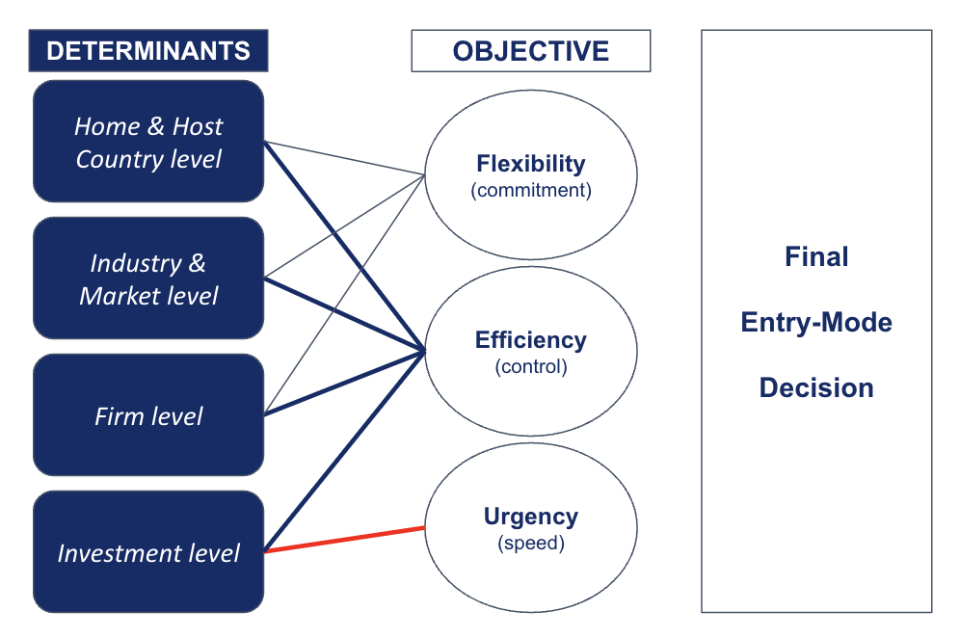
Figure 1. Foreign market entry mode determinants (Source: compiled by the authors based on Shen, Puig & Paul (2017))

These three objectives are affected by strategy, economic and institutional uncertainty, and resource & capability, caused in turn by four major determinant dimensions: Home & Host Country determinants, Industry & Market, Firm and Investment (Shen, Puig & Paul, 2017).

The first level relates to Home & Host country determinants. Here the focus is on the political, institutional, and macro-economic environment, as well as the geographic distance of this country. These variables can influence the strategy employed by the company or be proper “blocking factors” that force the company not to undertake the market entry as in the case of strict regulations and trade barriers, which may lead a company to employ a strategy over another (Glowik, 2020, p. 85). The expected reaction of local competitors can potentially be a determinant too, especially when taking into account that some entry modes are perceived as more aggressive than others. (Glowik, 2020, p. 85).

Local Incentives are also to be considered. Several countries set up tax benefits, provide firms with support for infrastructure development and other kinds of incentives for foreign subsidiaries, which at parity of efficiency (relative to home production) may trigger additional cost savings for the company (Glowik, 2020, p. 82). It is definitely not a secret that the majority of countries see Greenfield FDI as the major source of growth for their economy, as opposed to acquisitions (Gopalan et al., 2019). This government’s regulations and programs may also favor this kind of investment in situations where trade barriers are present (Glowik, 2020, p. 92). However, in employing such an entry mode, additional disadvantages may arise from the limited knowledge of the foreign environment or due to the political landscape of the foreign country. Moreover, cultural differences will definitely involve cultural adjustment costs (Glowik, 2020, p.82).

Joint Ventures, on the other hand, often represent a solution to enter a foreign market when there are huge institutional differences (legal and political), and disincentivizing international trade policies. A partnership with a local firm allows the MNE to acquire the managerial experience needed to deal with the unfamiliar foreign environment without having to fully commit resources (financial & non-)(Beamish & Lupton, 2016).

Overall, however, the effect this variable has on the MNE’s choice is rather moderating (Chiao, Lo & Yu, 2010, p. 355). This in the sense that strategic objectives or a firm's resources are the first considerations the company makes, then the foreign country's institutional environment may, or may not, influence this decision.

Another important role is played by industry and market determinants. Here we consider the attractiveness of a certain market (the size, growth potential, uncertainty of the market), entry barriers (costs, level of competition, access to resources), exit barriers and Industry asset specificity (technology and marketing intensity). As reported by Glowik (2020), “attractive forecasts for a foreign market identified by market volumes and promising growth rates, recommend a local presence instead of serving the market from distance” (Glowik, 2020, p. 86). Also considerations tied to the product and industry margins may play a huge role in this decision, favoring contractual forms as these margins are more thin (Glowik, 2020, p. 86).

Relative to the market size, as wholly owned subsidiaries provide MNEs with better opportunities for scale and lower marginal costs, they will lead to enhanced profitability in comparison to a Joint Venture and thus the MNE will prefer them (Rizwan & Chen, 2011, p. 134).

As for the market uncertainty, Joint Ventures are often employed to deal with such risks, such as the ones deriving from significant economical, political and financial risks. As an example, with regard to exchange rate fluctuations, firms show a tendency to employ a strategy of ownership and control when the fluctuations are minimal, but when those are seen as a major risk, a joint venture is likely to provide additional protection (Chen & Hu, 2002, p.141).

The next determinant focuses on firm-level, that is the capabilities and resources of the organization (both financial and non-financial), the degree of experience and specificity of the asset owned.

The desire to have full control over foreign activities through a wholly owned subsidiary may in fact arise not just from the level of technology of the firm, but also from the specificity of the asset owned. In case a firm controls unique processes and know-how, it doesn’t only want to maintain this knowledge internally, but wants in addition to make sure that they are managed effectively (Chen & Hu, 2002, p. 134).

Aside from non-financial resources, financial ones also play evidently a major role, especially in capital intensive industry. It is true that companies face resource constraints which prevent them from exploiting all the opportunities that arise in the market (Jung, Beamish & Gorzen, 2010, pp. 270-271). However, the bigger the amount of resources the firm owns, the lower the perception of costs and risks, which might lead companies to prefer a strategy such as Greenfield FDI. Similarly, non-financial resources, such as having a well established support and logistic network in the foreign market can lower significantly the risk of investing for the MNE, which will therefore establish a Wholly Owned Subsidiary (Chiao, Lo & Yu, 2010, p. 354).

Where those advantages are not present, setting up a joint venture may be the preferred choice for a company for several reasons.

Firstly, depending on the firm’s size an International Joint Venture might appear as the wisest choice as they might provide the company with the financial assets it needs to enhance or maintain its competitive position (Glowik, 2020, pp.78-79). This does not necessarily mean that the smallest companies will prefer to set up a joint venture, while larger ones will decide to pursue a Greenfield FDI. Despite, generally bigger companies suffer less of resource constraints, it also true that they may face them while growing, and this situation might push the company to set up a Joint Venture in order to achieve more flexibility and reduce the burden of resource constraints (Jung, Beamish & Gorzen, 2010, p. 270 - 271, 289).

Similarly, for managerial experience, operational capacity and networks of suppliers. The competitive advantage of a joint venture may arise not only from pooling financial capitals with another entity but also by pooling HR resources, R&D and operational capabilities. This may positively affect the company by allowing it to achieve economies of scale and/or achieve cost reduction, and may help the company increase its sales capacity in a foreign market by operating with someone who is already well established, and therefore increase its bargaining power (Glowik, 2020, pp. 78 - 79).

Thirdly, also for Market knowledge and International Experience. Firms with lower level of experience and knowledge of the foreign market tend to rely more on local knowledge, thus setting up Joint Venture to balance liabilities deriving from inexperience (Chiao, Lo & Yu, 2010, p. 354) and avoid incurring excessive resource commitments (not only financial) (Glowik, 2020, p. 78). As a result, the establishment of an international joint venture may speed up the internationalization strategy of the company.

Some other considerations arise from the company’s structure, and the CEO characteristics (Shen, Puig & Paul, 2017).

Researchers have also devoted attention to investment and business level determinants. In this sense Glowik (2020) has repeatedly stressed out the key role that the strategic objectives of the firm in the target market have, especially with regard to timing and spatial proximity. Indeed, depending on these two factors the firm may increase or reduce the desired amount of control it has over its foreign operations, turning to trade strategies when the required entry speed is rapid, and to strategies of ownership and control when there is the need of be as close as possible to foreign operations (Glowik, 2020, p. 83).

The market entry timing is in turn influenced by several other factors such as the need to follow an important client or competitor in the foreign market, the threat of product substitution, the intensity of competition, investment volume and exploiting first-mover or latecomer advantages (Glowik, 2020, pp. 85-86). Greenfield FDI in this case represents quite a cumbersome way to enter the market due to all the organizational delays a company may suffer and the increased planning and coordination needed (Glowik, 2020, p. 83).

On the other hand, the spatial proximity, will depend mostly on the product or the service the company is going to sell, where standardized products will allow for less “controlled” entry modes, such as contract manufacturing or licensing, while an increased need for personalization will call for a strategy of ownership and control (Glowik, 2020, p. 86). However, generally, maximum control over abroad resources favors:
- a better alignment with the overarching strategy of a Multinational Corporation, which may not happen in case of a Joint Venture due to the organizational misalignment that could derive from two separate firms with two different goals in mind and the opportunistic behavior of the partner (Beamish & Lupton, 2016 p. 5). Moreover, the cultural and working differences between managers may represent another additional obstacle to the successful completion of the partnership (Glowik, 2020);
- a better flexibility in terms of capturing customer expectations as in the case of not-standardized and highly personalized products or following customers entering an host country. This is because customer intimacy can be positively influenced by spatial proximity (Yeung, 2022, pp. 276-277);
- protection of knowledge spin offs, especially in case of an advanced degree of technology of a specific asset or managerial knowledge (Glowik, 2020, p. 85). In fact, in previous research, it was found out that the higher the level of technology a firm owns, the more likely it is the MNE will pursue a strategy of ownership and control (e.g. Greenfield FDI) in order to protect both core competencies and proprietary technology (Chiao, Lo & Yu, 2010, p. 353). Moreover, as stressed out by Dunning, being crucial resources for a company, the MNE wants to make sure to grasp all the benefits it can from its proprietary technology, to fully capitalize on them (Dunning, 2001). This may not happen in the case of joint ventures due to the risk of knowledge outflows (Beamish & Lupton, 2016 p. 5);
- to fully capitalize on this advantage when the objective is linked to cost savings (Glowik, 2020, p. 82);
- to have enhanced control over difficult logistic processes (in the case of heavy and bulky products) (Glowik, 2020, p. 86);
- enhanced control over the brand reputation and quality (Glowik, 2020, p. 92).

Other factors tied to business level determinants are:
- reputational damage the company may incur as a result of discontinued operations, which may be avoided or mitigated with the formation of a joint Venture to boost performances (Glowik, 2020, pp. 78-79);
- the time horizon of expected Return On Investment and the investment volume. As these metrics grow, the uncertainty and associated risks grow with it, allowing for entry modes which historically have a more mitigating effect, such as joint ventures (Glowik, 2020, p. 86);
- finally, companies invest in foreign markets not just to exploit their competitive advantage but also, in the long-run, to create new ones. This may of course include the access to financial resources to fund new projects, but also raw materials, technology and knowledge, that will be fruitful in the long term. For these reasons an MNE will prefer a Joint Venture (Chiao, Lo & Yu, 2010, p. 353).
To conclude this first subchapter, we must also point out the interrelation between the choices to own a subsidiary fully or jointly in a foreign country. Raff highlights in his article “The Choice of Market Entry Mode: Greenfield Investment, M&A and Joint Venture” how the likelihood of Greenfield Investment affects the choice of outside local firms, and therefore at last, of the MNE. His study shows that when greenfield FDI is more profitable than other trade strategies, the price of local firms significantly declines. Therefore, as they become more “affordable”, the probability that the MNE will choose an M&A increases (Raff, Stahler & Ryan, 2007).

1.2 Existing research on Greenfield FDI and Joint Ventures by International Microelectronics companies
In the next two sections we will dig deeper into the entry strategies we discussed above by targeting specifically the microelectronics industry.
Microelectronics companies
Depending on the perspective we adopt, the industry may be divided in several different ways: by product, by segment of the value chain or by application.
By product they are divided into: Discretes, Optoelectronics, Sensors & Actuators and Integrated Circuits (memory, logic, micro and analog) (WSTS, 2017).
Some other researchers in the industry tried to draw a division by segment of the Value chain dividing the sector in Foundries, Design Houses and Integrated Device Manufacturers (Li, Huang, Chen, 2011), IP designers, EDA Companies (Macher, Mowery & Simcoe, 2002, p. 4).
The last division concerns the applications of these devices. However being the range of applications quite wide and the technological advancements in the industry considerably rapid we lack a comprehensive perspective on this subject.
To spend just a few words regarding the industry itself: previous research highlighted key dimensions affecting the industry structure in microelectronics. First and foremost, Moore’s law, rule that states that the number of transistors within a chip doubles almost each two years, increasing computational power and decreasing costs. This naturally plays a crucial role in the industry, affecting in particular competitiveness (Schaller, 1997) and highlighting the major role played by R&D expenditures in the industry (Khan, Hounshell & Fuchs, 2018). Moreover, two final considerations regard an enhanced competition over commodity products (Flamm,1993) and the increasing costs in order to build a fab (Imboden et al., 2014).
Previous research on Greenfield FDI and Joint Ventures by International Microelectronics Companies
Previous research had as major subjects of interest localization of the foreign facility and business objective of the facility (were they investing in R&D, design, production or assembly and packaging?). In line with our work in the previous section we use the same frameworks dividing determinants in: Home & host country, Market & Industry environment, Firm, and Investment Level Determinants.
As for the home and host country level determinants, previous research focused mostly on the lower cost of labor, foreign government’s incentives, and trade barriers (tariff rates and pressure by local governments). This last point made servicing a market through export extremely unattractive for foreign companies which preferred to operate through other organizational forms (Yoffie, 1993, pp. 201 - 203). Another analogous case in this sense is in Japan, where, especially during the first wave of FDI the government supported the indigenous industry with several protectionism measures, making investing in Japan quite unfavorable for several companies in the industry (Yoffie, 1993, p. 203). The same happened for Chinese companies in other countries (Luo & Lemanski, 2016).
Cultural distance is also cited in several researches, where the need for a smoother integration into the local market and to overcome cultural barriers can push firms to prefer a certain entry mode over others (Hu & Ma, 2012).
As for the Market and Industry environment major researchers highlighted the influence it has in several aspects of the entry strategy but mostly on timing. Depending on the product strategy the company adopts, it may need to adjust the rapidity through which it enters the market, and indirectly have an impact on the choice of entry mode. In this sense, the competitive landscape and rapidity of technological advancements undoubtedly influence this decision as well (Park, 2020).
Firms which operate in concentrated and high-growth industries prefer to maintain control over foreign operations and leverage technological advantages. The situation may change in industries characterized by scale, in this case joint ventures or acquisitions may represent a valuable alternative to share costs or leverage established market presence (Elango & Sambharya, 2004).
Similarly, according to studies on the choice of entry mode in manufacturing companies in industries characterized by imports and by High demand growth rates firms would prefer greenfield rather than other types of FDI (we can extend the validity of the study to specific segments of microelectronics, such as foundries and equipment) (Elango & Sambharya, 2004, pp. 118 - 119).
As for firm's capabilities a major role seems to be played by resource availability (both financial and non-financial), in a trade off between the amount of resources a firm can commit and the demand for such products. When taking into consideration resource commitments, the increasing costs to build a fab or an R&D facility, have a central role in influencing the entry mode decision. Furthermore, the level of technological advancement of the products marketed by the firm impacts the firm’s choice on how to enter a foreign market, in particular for the need to avoid technology spillovers and protect intellectual property, but also to ensure proper quality. The presence in the foreign market then, could be greatly influenced by the experience the company has gained in terms of distribution and sales channel management (Glowik, 2020).
Strategic considerations and Investment level Determinants concern the necessity to develop innovation capabilities, as certain modes better allow access to engineering talent, technology, capitals, and to be closer to customers (Yoffie, 1993, pp. 208 - 210). Asset seeking considerations are also highlighted in more recent literature as one of the main concerns of companies while preparing the strategy to enter a foreign market (Luo & Lemanski, 2016, pp. 623 - 624).
Valuable alternatives in this sense could be represented by licensing. However, the fact that several companies do not possess patents valuable enough to justify cross-licensing and that one-way licensing is risky due to knowledge spin-offs, can push firms to establish their own subsidiaries (Yoffie, 1993, p. 202). Similarly functional collaborations in either manufacturing or logistics are found to be important factors affecting the choice of a Joint Venture as they could boost performance of the company (Ku, Gurumurthy & Kao, 2007, p. 300). These efficiency effects are seen as major factors determining the formation of a Joint Venture (Gugler & Siebert, 2007).

1.3 Previous research on Greenfield FDI and Joint Ventures by International Microelectronics companies in developing markets
After having set a clarification on developing markets we will follow the framework that we have implemented throughout the previous two sub-chapters to uncover what previous literature has found out about these two entry modes, specifically in these kinds of markets. We have to admit that, despite the increased interest in the sector, not much attention has been devoted to the research on these investment strategies towards developing markets in the industry. Therefore, except for three papers dedicated exclusively to the semiconductor market, we will draw information from papers about the (broader) electronics industry.
Developing Markets
Despite the definitions of developing markets being several, and each of those based on distinct factors, for the purpose of this paper we decided to avail ourselves of the classification given by the International Monetary fund.
As no uniform and formal definition is identifiable, the definition provided by the IMF would be a good fit for his broad nature, based on three diverse factors: Systemic presence (nominal GDP; population; share of exports in global trade), Market access (share of a country’s external debt in global external debt; its inclusion in global indices used by institutional investors; frequency and amount of international bond issuance) and Income level (GDP per capita in nominal US dollars).
Based on that several different countries are to be excluded from the classification of advanced or developed economies and therefore fall into the aggregate of Developing ones. Countries such as Brazil, China, Malaysia, Vietnam and others from Europe, Africa, Americas and Asia fall into this category (IMF, 2024).
Home and Host Country Determinants
Despite it seems to us that the companies in the industry have assumed a political character throughout the last years, we have found out that host country determinants have played a significant role in the entry mode choice since the first foreign investments of Semiconductors firms. As reported by Yoffie in his article, the first wave of Foreign Direct Investment in semiconductors (’60 – mid 70’ ca.), was primarily affected by cost considerations. Therefore, the direction of the FDI flows was mostly targeted to developing markets. Given the fact that this phase of the manufacturing process required low-skill labor that could yield up to a 50 percent reduction in manufacturing costs, US based producers started to establish operations abroad, especially in Latin America and Southeast Asia. These Investments were also supported by local governments, which offered significant incentives to firms to attract capital (Yoffie, 1993, p.201).
Another important aspect in this sense is when firms find themselves to deal with trade barriers. In order to penetrate a closed market chinese electronics companies showed a tendency to employ a Joint Venture type of entry mode the majority of the time, followed by Greenfield FDI as second preferred entry mode type (Luo & Lemanski, 2016, p. 623). A similar tendency is shown by foreign companies in China prior to 2008, where the only way to operate in the Chinese market was to set up a joint venture with a local state-owned enterprise (Yinug F., 2009, p. 4). The situation Changed then considerably when the Chinese government understood that state owned enterprises were not the right fit to make the microelectronics industry flourish in the country and started to liberalize the industry, set up sets of incentives and adhere to international rules (e.g. WTO), which significantly reduced the uncertainty of dealing with the Chinese environment (Yinug F., 2009, pp. 4 - 6).
As a factor preventing Greenfield FDI on the other hand we have environmental uncertainty (such as political or economical instability of the foreign country). This is mainly due to the lower prices for acquisitions and quicker establishment they have by acquiring a local company (Li & Xiong, 2022, p. 5). Similarly other types of political hazards have the effect of deterring greenfield FDI in semiconductors manufacturing (Henisz & Macher, 2004, p. 549).
On the other hand, Joint Ventures with a local partner may be able to better navigate the uncertainty of the environment by serving itself of the increased knowledge in the market (Yoffie, 1993, p. 220). This holds true unless the perceived risks of the company are not considerably lowered by other considerations, as for example having a customer in that country and an already well established network. One example in this sense can be drawn by Toshiba, LG, Philipps (and other Korean firms) in Poland where having an already well established customer and logistic network played a major role in foreign companies' decision to enter that market by setting up manufacturing facilities near the customer’s location (Glowik, 2020, p. 156).
Additional factors affecting the entry mode choice derive from the home market policy in terms of building an International Presence. In this sense, countries, and especially the Chinese government, may support companies who are entering a foreign market through FDI, compensating for the learning that would normally occur during the exporting phase (Luo & Lemanski, 2016, 625).
Industry & Market Determinants
Here the increasing propensity of companies to undertake a joint venture as the price to establish a new fab or R&D center increases, are good proof of the role that industry environment has in the companies choice (Yoffie, 1993, p. 220).
More broadly, research found out that where the industry environment uncertainty is low, with regard to Market Demand Stability, Regulatory stability, Competitive dynamics, technological change and supply chain stability, but the institutional environment is uncertain the MNE will prefer to set up a joint venture and/or other cooperative strategies. However, when the uncertainty of the industry becomes high and the institutional environment is also uncertain, the company will prefer to set up a new plant through greenfield FDI or resort to alternative ways such as exporting (Li & Xiong, 2022).
An additional determinant is represented by prior market entries of a firm and other firms’ market entry modes operating in the same sector in a particular market, which have an effect especially on organizational learning and legitimacy of entry mode choice, pushing in certain cases the MNE to reiterate the same entry mode decision (Ogasavara, 2013). In the same sense the study by Henisz and Macher provides similar results, supporting further the idea that the previous entry of other firms from the same home country influence the choice of a company to build from scratch a semiconductor manufacturing facility in a specific target market (Henisz & Macher, 2004, pp. 545 - 549).
Firm Level Determinants
Firm’s size (in this case in terms of production capacity) remains a crucial leitmotiv In the choice of foreign direct investment of a semiconductor firm, especially when we’re talking about Greenfield FDI (Henisz & Macher, 2004, p. 545).
Similarly a Greater level of international Experience shows a positive correlation with the choice of Greenfield FDI (Lee, 2010, p. 544). Here the researcher also provided statistical evidence of the influence of Asset-Specific Advantages and Capability-Specific Advantages in the choice of market entry mode.
Firms with larger size, financial support and firm-specific assets, as well as Technology know how, R&D capabilities, Managerial experience and ability to differentiate the products prefer to set up Wholly Owned Subsidiaries in a foreign market rather than set up a Joint Venture (Lee, 2010, p. 544). Especially technological know-how has been found to have a positive influence on the firm’s choice to undertake Greenfield FDI in the industry, due to the ability of firms to exploit this competitive advantage, to maintain tight control over their tech assets and because they are generally more able to deal with uncertain environments (Li & Xiong, 2022).
For Joint Ventures a main concern can be related to the fact that most non-local firms can have difficulties with recruiting the most talented engineers and selling products to large local groups. Thus establishing a partnership with a local representative allows foreign firms to successfully deal with the problem (Yoffie, 1993, p. 220). The establishment of a joint venture in partnership with a local partner may help the company to “reduce the liability of foreignness” (Martin, Mitchell, Swaminathan & Stewart, 2010, pp. 1792 - 1793). One main example is the Joint Venture formed by LG Electronics with Philipps which allowed the Korean MNE to serve itself of the brand and distribution network of Philipps in America and Europe and overcome the “cheap - imitative manufacturer image” it had developed in those markets, as well as to pool financial capital (Glowik, 2020, p. 155). Moreover, in case the firm’s technological capabilities do not significantly mitigate the risks posed by environmental uncertainty Joint Ventures would be preferred, as they allow for risk sharing and can provide local knowledge and resources (Li & Xiong, 2022).
Investment & Business Level Determinants
In several studies regarding the electronics industry it has been highlighted how these determinants play a major role in the company’s choice of entry mode. One main example is Glowik’s work on Market Entry Strategies (2020) and in particular the case study of Samsung exposes the cruciality of this dimension. Instead of focusing on home market determinants (perceived cultural and geographic distance) the case study shows how Samsung always tried to pursue operational flexibility to respond quickly to market needs. In order to be able to do so Samsung set up several global sales offices in different countries. It is true on the other hand that the possibility to react quickly to market opportunities comes along with great managerial experience, financial capabilities and a well established international network (Glowik, 2020, pp. 146 - 147).
In this sense another study carried out by Luo & Lemanski on three major electronics firms from China (Lenovo, Huawei and Haier) helps us to shed some light on the strategic consideration related to the internal capabilities of the firm. While not at their prime, these kinds of firms weren’t able to compete with major players in developed markets. On the other hand they preferred to employ FDI opportunities towards developing markets in order to fully capitalize on their competitive advantages (Luo & Lemanski, 2016, p. 621). Market seeking considerations were the main reasons behind the market entry modes of these companies, which in 63% of the cases preferred to employ Greenfield FDI (Luo & Lemanski, 2016, pp. 623 - 624).
The need to acquire specific technological capabilities also seems to be a crucial determinant in the choice of International Microelectronics firms to invest in foreign markets. Depending on the level of technology of the foreign market there is also a trade-off between political hazard and technological capabilities. With smaller firms willing to invest in countries with a high level of technology even though they have an uncertain or risky political environment, while bigger and more advanced companies prefer to invest in lower risk but high technology countries (Henisz & Macher, 2004, p. 550).

Chapter 2: The Microelectronics Industry: AT&S’ Greenfield FDI and Applied Engineering, Inc. Joint Venture in Malaysia
In this chapter we will perform our analysis on the global semiconductor industry and on developing markets to bring to light potential factors affecting the choice of a Microelectronics company entering a new foreign market. We will then dig even deeper into details with our two case studies (AT&S and Applied Engineering in Malaysia) to give a practical imprint to our analysis as well as to assess factors which are not easily identifiable with a general analysis.
To restrict even further our research of the semiconductor industry and being that several developing economies (IMF definition) do not have a relevant microelectronics industry (1bn + in revenues), we excluded them from the scope of our research. Therefore, at the end, our selection includes 13 countries: Brazil, China, Hungary, India, Indonesia, Malaysia, Mexico, Philippines, Poland, Romania, Russian Federation, Thailand, and Vietnam (Statista, 2023).
In our analysis we will alternate statistical and mathematical methods (to quantitatively assess the impact that some factors can play in the firm’s choice to undertake a specific strategy)with the analysis of the case studies to uncover more specific determinants and test whether the previous ones still hold true.

2.1 Industry Analysis and Microelectronics Industry in Developing Economies
The Microelectronics Industry, as anticipated in the first chapter is a subsegment of the Electronics one. The two are inevitably tied as microelectronics products are a vital component of every electronic device in our world.
A perspective we can adopt in order to facilitate our analysis is dividing the players in the industry by segment of the value chain. This type of division has been already adopted in previous research, leaving nonetheless out of industry classifications some important segments which are now key to industry growth. Therefore we decided to integrate the previous research with other players in the industry which contribute to the overall value chain (see figure 2).
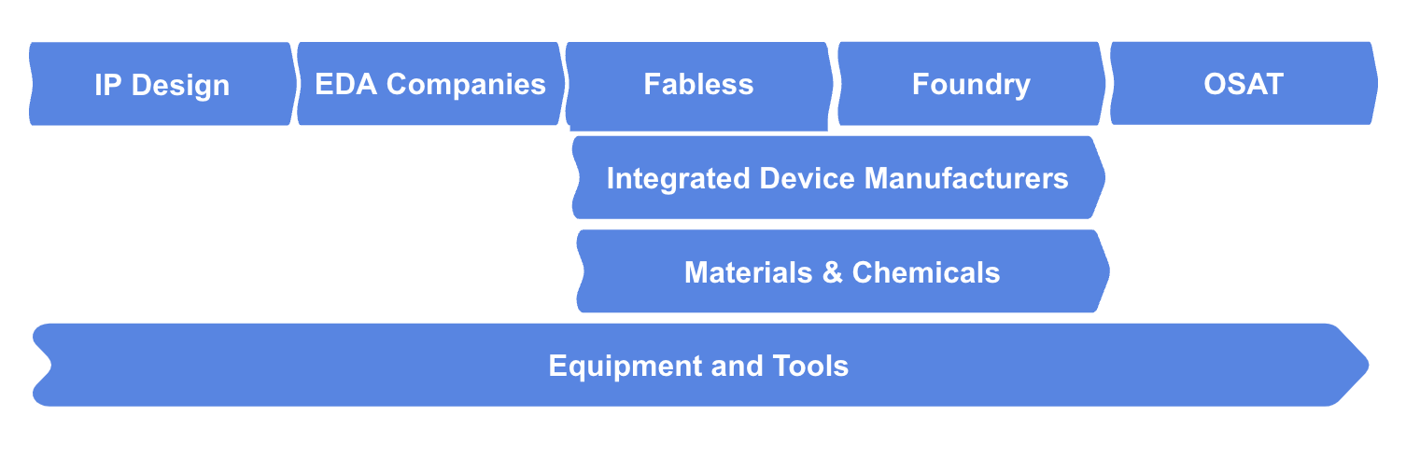
Figure 2. The division of the Semiconductor Industry by segment of the value chain (Source: compiled by the authors)

According to the specialization they have, and the function different companies accomplish within the industry we may identify at least eight different segments of the value chain:
- IP Core Designer, dealing with the design of the building blocks of microprocessors, but not selling any tangible product;
- EDA companies, which integrate and extend the previous designs by using automation tools;
- Materials and Chemicals, specialized in extracting, transporting and selling the materials and chemicals needed in order to manufacture semiconductors;
- Equipment and Tools, concerning the production of tools and equipment (and services) needed to physically manufacture the chips.
- Fabless companies, which integrate (for their own use or for other companies) the previous designs of IP and EDA stages and “send” those designs to foundries that will manufacture microchips for them.
- Integrated Device Manufacturers (IDM). These companies accomplish the same tasks of the fabless ones but keep the manufacturing processes internal.
- Foundries. Companies that make chips for others, but are not involved in the design process of the microchips.
- OSAT (Outsourced Semiconductor Assembly and Test). Facilities to run tests on the semiconductors in order to assess whether they were successfully manufactured.
Within each one of this segment we can identify several additional separated companies based either on the function they perform in support of other players in the value chain, or on their outcome (products or services they produce).
Regional Specialization
The microelectronics value chain has a global configuration with 6 major regions (US, China, Japan, Taiwan, Europe and South Korea) contributing 8% or more to the overall value chain (BCG & SIA, 2021).
Overall sales in the industry touched their all time high in 2022 with $574.1 billion of sales across all markets, decreasing then by 8.2% in 2023 when they amounted to $526.8 billion. Annual sales decreased in almost all the regional markets, with the exception of Europe which saw a 4.0% increase throughout 2023. A double digit decreasing curve is noticed in China and Asia Pacific, by 14.0% and 10.1%, respectively, a single digit decrease in Americas and Japan, 5.2% and 3.1%, respectively. This changes, due to supply chain disruptions and the need for proximity to key customers, might highlight that patterns of specialization are changing in the industry. The market is expected to rebound, at least partially, during next year according to the Semiconductor Industry Association (SIA).
However, data extracted from UNCTAD and STATISTA’s databases shows that the trend is not yet disrupted with a continuous dominant position of developing economies in terms of Annual Revenues (see figure 3) and Exports of Electronics devices and Electrical Components (see figure 4).

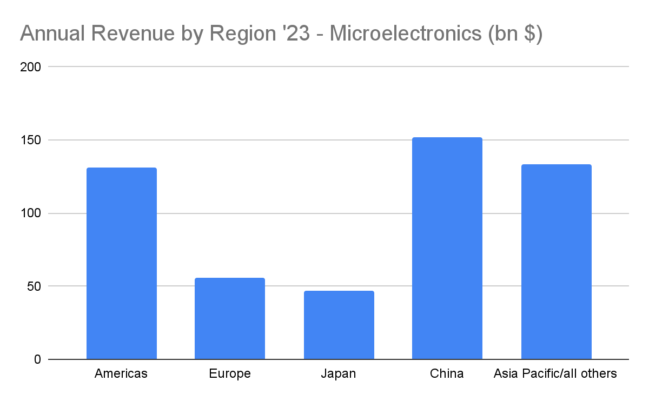
Figure 3. Annual revenue of the microelectronics industry by region (Source: compiled by the authors based on data from STATISTA)

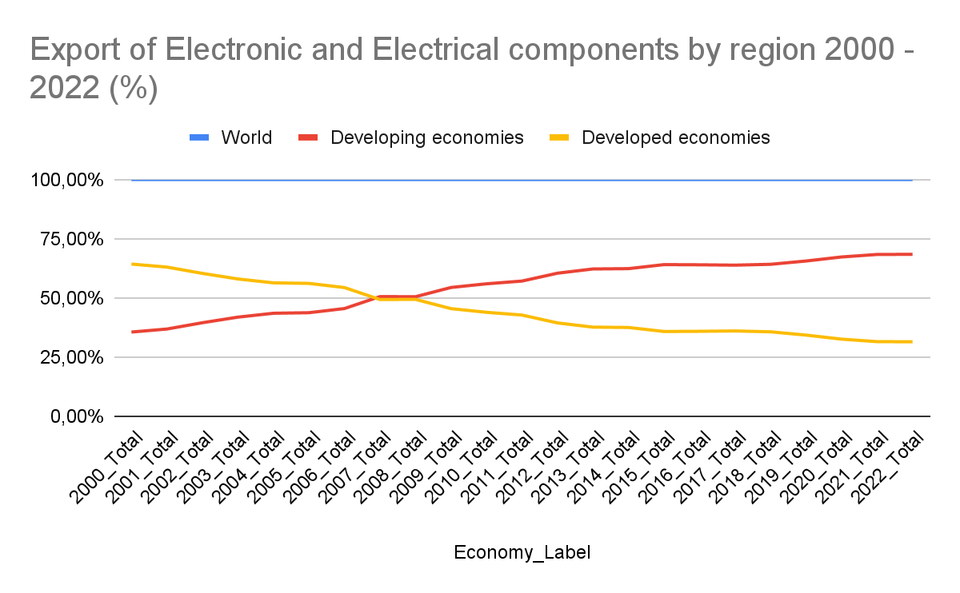
Figure 4. Export of electronic and electrical components developing vs developed markets 2010 - 2022 (Source: compiled by the authors based on data from UNCTADSTAT)

The dynamics of the industry are characterized by a marked specialization of value chain segments by country with Design stages happening mostly in Europe and US, Materials and Equipment from US, Japan, South Korea and Europe, Manufacturing happening in Taiwan, US, China and assembly and Packaging in South East Asia (mainly Malaysia) (see figure 5).
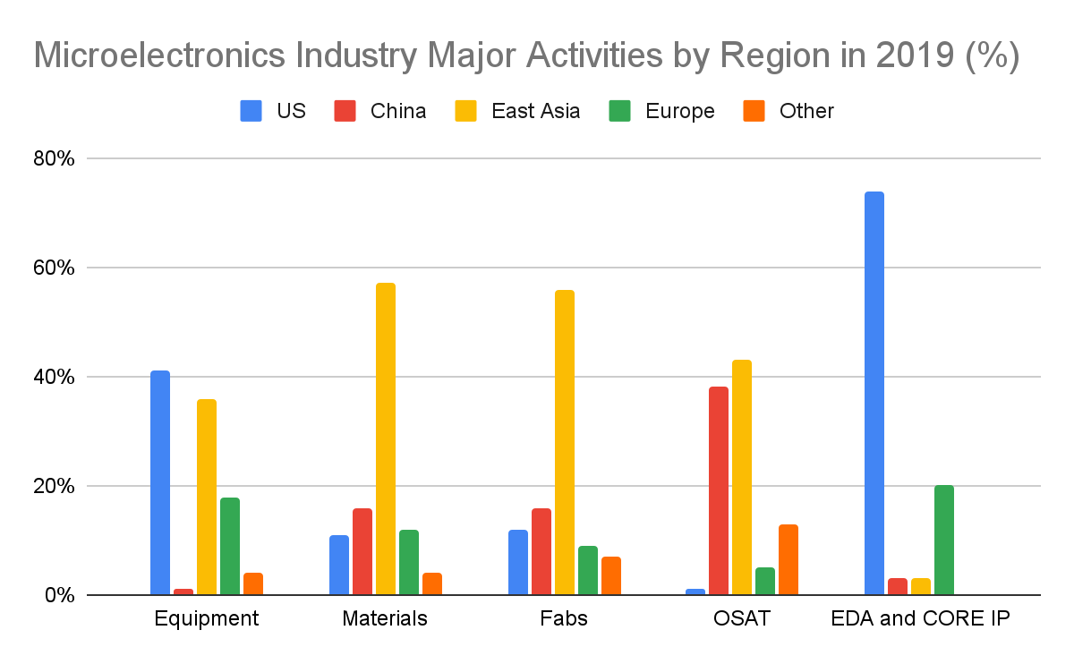
Figure 5. Microelectronics Industry Major Activities by Region (%) . (Source: compiled by the authors based on data from BCG & SIA (2019))

Among Developing economies China is the leading market in terms of production and Innovation, making up for more than all the other developing economies assembled together (see figure 6).
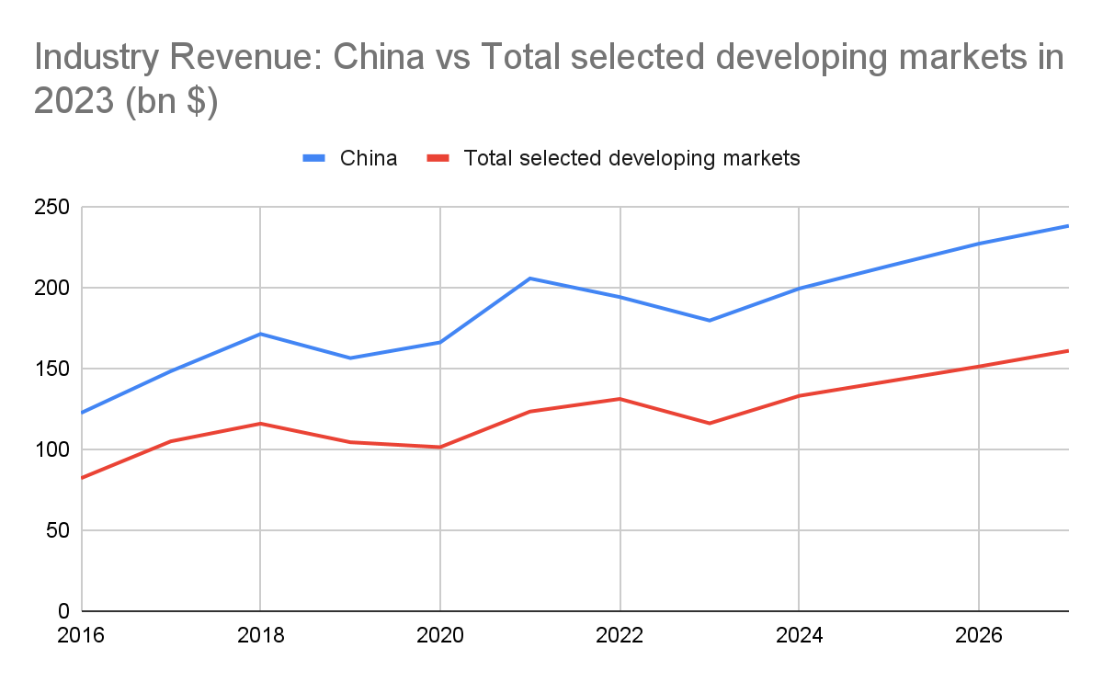
Figure 6. Industry Revenue: China vs Total selected developing markets (bn $) (Source: compiled by the authors based on data from STATISTA)

Other Developing Countries, especially from the Americas and Asian region are steadily increasing their growth thanks to downstream activities, i.e. manufacturing, assembly & Packaging.
In Particular, South East Asia is rapidly increasing due to proximity to customers (electronics companies) (see figure 7).
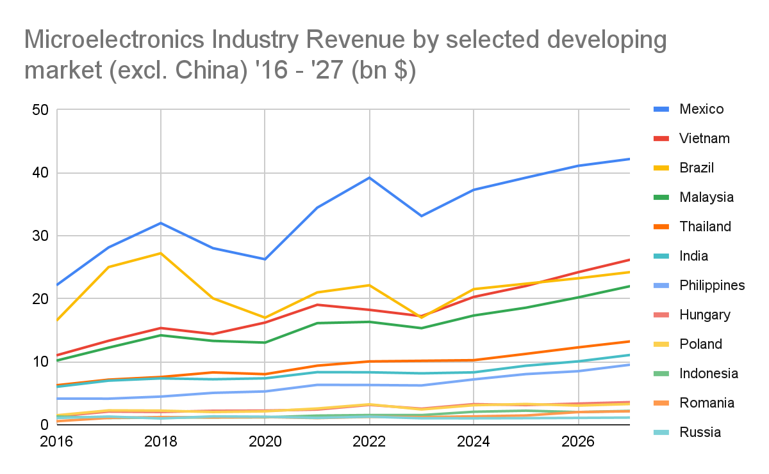
Figure 7.Microelectronics Industry Revenue of selected developing markets (excl. China) 2016 - 2027 (bn $) (source: Source: compiled by the authors based on data from STATISTA)

Competition
The top 10 companies in the industry by revenue are TSMC, Intel, Samsung (electronics division), Qualcomm, Broadcom, Nvidia, SK Hynix, AMD, STMicroelectronics, Apple. These 10 companies form two thirds of the total market in terms of revenue deriving from semiconductor activities. Here below you can find a composition of the total semiconductors’ industry revenue (see figure 8).
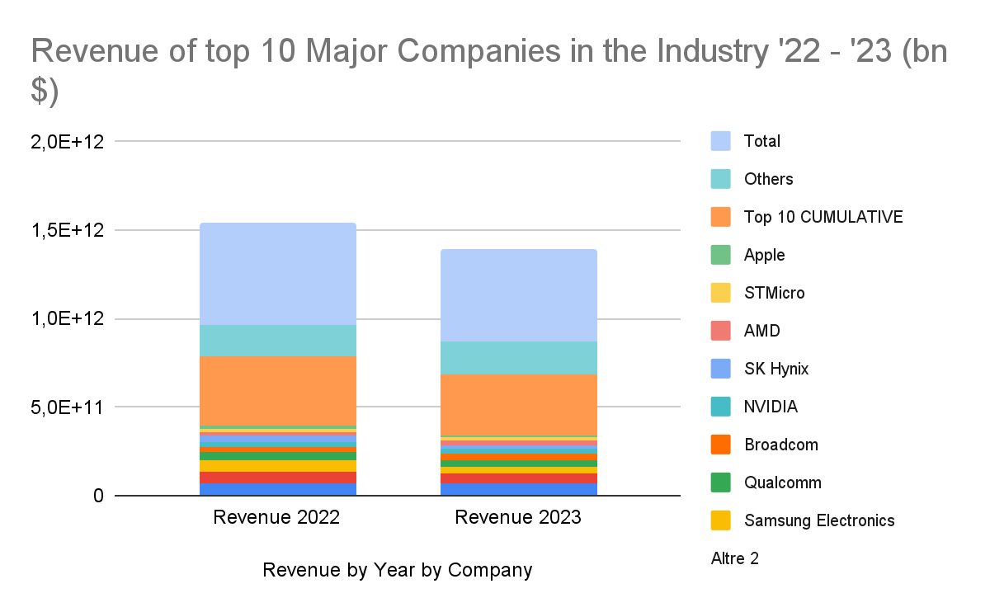
Figure 8. Revenue of top 10 Major Companies in the Industry ‘22 - ‘23 (bn $). (Source: compiled by the authors based on data from STATISTA, Gartner).
If we apply the HHI to this specific analysis we would obtain a result of 1726 for 2023, showing a moderately concentrated market. The competitive behavior arising from such concentration can have positive effects on innovation, posing however some barriers to entrance of smaller firms.
Know-how and capital barriers
The Microelectronics industry is characterized by a marked speed of innovation, with a constant drive to produce smaller chips and in cheaper ways (as predicted by Moore's law) but also to produce them faster and to be less energy intensive. This pushes companies to continuously innovate and shortens the technology life cycles of the industry’s outputs, which usually last up to three years (Rapp, 2022). Microelectronics companies are quite used to investing large sums of capital as a strategic move to ensure they maintain their competitive positioning and this led to a significant increase in the capital spent in the industry (see figure 9).
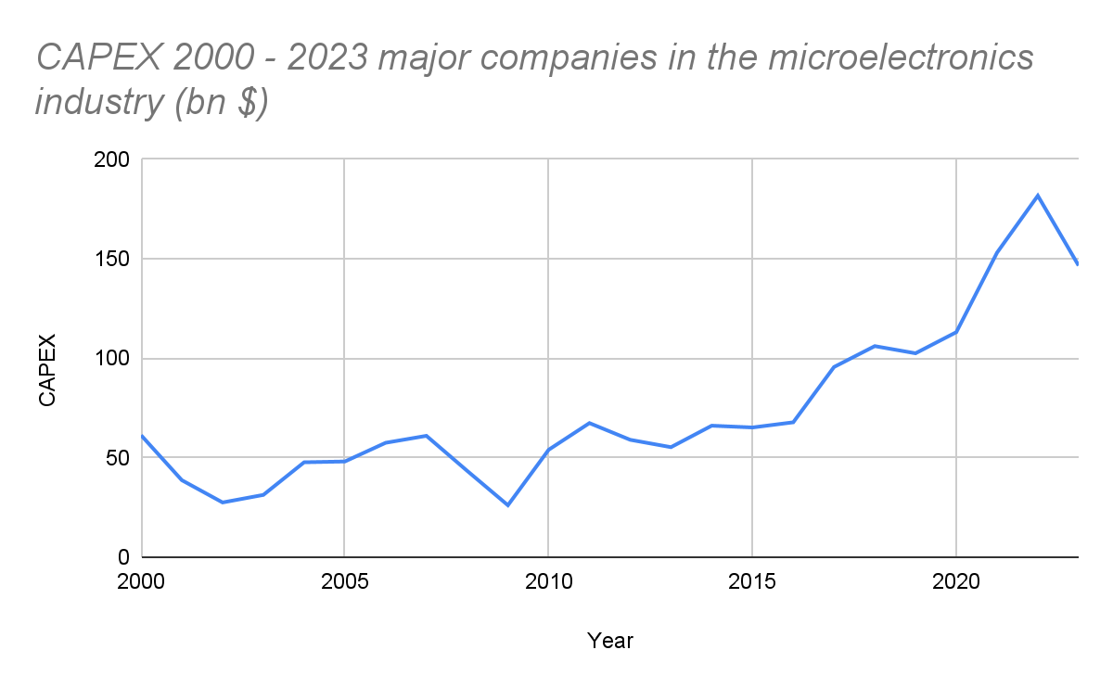
Figure 9. CAPEX of major companies operating in the microelectronics industry ‘00 - ‘23 (Source: compiled by the authors based on data from FDi Intelligence)
According to our calculations base on FDi Intelligence data, a great part of this CAPEX has been spent over the last 3 years, amounting to 41.86%. These expenditures have two main directions: R&D and FDI.
Overall the ratio R&D / Sales in the industry is 11.74% (13,72% in general semiconductors and 8,26% for semiconductors equipment). This figure is well above the total market average of 2,25% and second just to Biotechnology (39%), Pharmaceuticals (16,48%) and Softwares (~15%) (Damodaran, 2024). However in the latter case several of this kind of investments are targeted to the microelectronics industry. We can take as an example Apple which broke throughout the last year its record in R&D spending, directing the vast majority of these spending in the development and engineering of their M3 Chips (Yang, 2023).
As for the location of these R&D spendings we see that major investors are headquartered in developed markets such as the US and Europe, where companies reinvest on average 18% and 15% (respectively) of their revenue on R&D. The figure is considerably lower in Asian Developed Markets, where Taiwanese, Korean and Japanese companies respectively reinvest 11%, 9.1% and 8.3% of their revenues, and even lower for the highest spending developing market of the list: China. Here companies reinvest on average 7.6% of their sales on R&D (Zia, 2023).
However a great chunk of this R&D investments are made towards Developing Markets (in particular South and East Asian countries) by companies headquartered in the US or Europe. Major examples are Analog Devices with its major R&D center in India (where it is expected they will increase their operations with an additional billionaire investment), Microchip technologies in India, Marvell Technology in Vietnam and finally Intel with several R&D centers spread in different developing countries (Zia, 2023).
As for FDI on the other hand it represents 25.22% of the last three years' capital expenditures of microelectronics companies. Here 20 companies dominate the market, accounting for almost two-thirds of the total FDI projects. TSMC, Intel and Samsung lead the group (Irwin-Hunt, 2023).
The amount pledged to Greenfield FDI and Joint Ventures in 2023 in the semiconductor industry, amounted to $50.8 bn (Irwin-Hunt, 2024), decreasing in comparison to 2022 ($91.3 bn) (Irwin-Hunt, 2023), and 2021, where the overall value amounted to $56.6, (second and third place across all sectors for FDI, respectively) (Dettoni, 2022) (see figure 10).

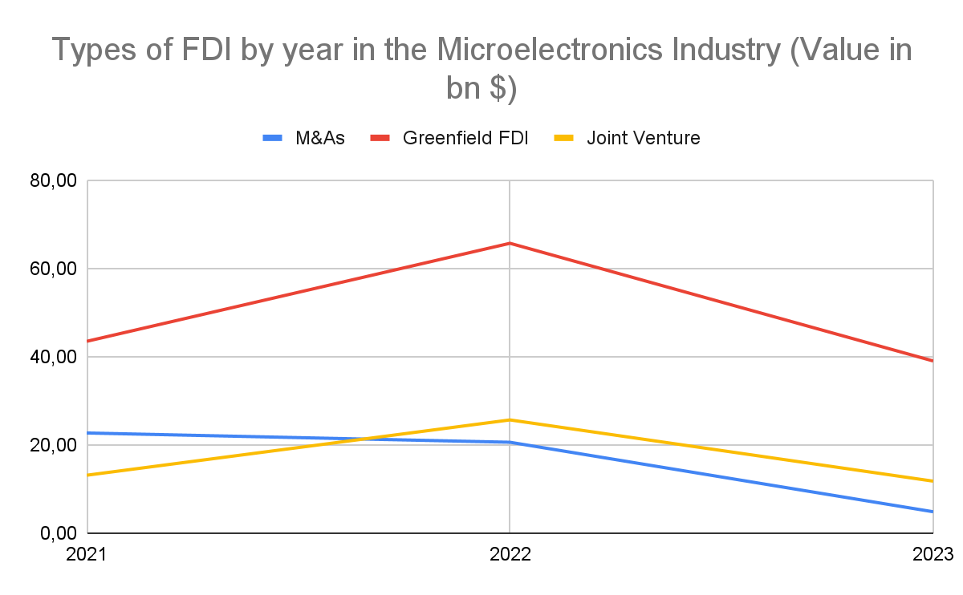
Figure 10. Types of FDI by Year in the Microelectronics Industry (Value in bn $). (Source: compiled by the authors based on data from Statista, ARTHOS Corporate Finance, Fdi Intelligence, IC Insights)
This rapid surge in Greenfield FDI is due primarily to the rising price to pay in order to complete an acquisition in the industry and to the increasing costs to build a fabrication facility, as well as the increasing amount pledged to R&D initiatives.
Moreover, increased tendency by local authorities to intensify scrutiny of M&A transactions (due to antitrust concerns), is also influencing companies’ choices. This plays a critical role especially in the interaction between Chinese and EU or US authorities with their respective microelectronics companies (Allen & Overy, 2023). Authorities’ intervention may in certain cases pressure companies to stop the sale of selected devices to specific countries as in the case ASML, AMD and NVIDIA’s interaction with the Chinese market (Koc & Jacobs, 2024; Lee, Hawkins & Bloomberg, 2024).
Among all the possible strategies greenfield FDI is taking the lead throughout the last years with several projects which broke the ground in the USA, Europe, Japan, China and India.
Similarly, Joint ventures are seen by companies as a valuable alternative with several monster deals announced by leading companies in the sector (especially from Taiwan with the JASM and ESMC projects breaking the ground in Japan and Europe, and Foxconn Vedanta Gujarat project in India). In the latter case, however, the company decided to pull out from the deal due to “concerns about incentive approval” from the Indian government (Blanchard, Vengattil & Kalra, 2023). We have several examples also specific to the malaysian market, such as EV Group and Dymek, Shenzhen HFC Co Ltd and JF Technology, TF Micro and AMD, Foxconn, Nvidia and others.
Statistical Analysis of selected entry modes
In order to uncover the determinants behind the choice of undertaking one or the other entry strategy to enter for the first time a specific foreign developing market we independently gathered a sample of 100 market entries in the 13 selected developing markets listed above. Although the Central Limit Theorem tells us that, as a rule of thumb, 30 entries should be enough to provide statistical evidence of some sort of correlation, we decided to provide 100 in order to give more robustness to our test. All the entries were browsed independently on the web using the same keywords and queries for each country, in English language. They are taken from news over the last 10 years on Microelectronics companies or companies which were setting up activities specifically for the Microelectronics Industry. The sample was gathered enabling each entry mode to be drawn (greenfield or JV) in each different country, taking into account already made deals and announced ones.
The sample was constituted by 69% Greenfield deals and 31% JVs, a percentage that holds for all developing markets except China, where it is the opposite (70% Joint Ventures and 30% Greenfield).
We observed that the average value of the top 10 Greenfield Deals is more than two times bigger than JV ones: $ 861 mln for greenfield against $ 401 mln for Joint Ventures.
We also observed that the revenue of companies undertaking a greenfield FDI is on average almost 6 times higher than the one of companies undertaking JVs: $10,3 bn for Greenfield against $1,8 bn for JVs.
This led us to believe we could find a correlation between revenue for the year the investment was made and choice of entry mode. The correlation appears to be moderate (r = 0,40), making us believe that while there is some level of association there are certainly other factors affecting the choice.
In the same way, we then regressed the number of patents (for the year of the planned market entry) against the choice of Market Entry between Greenfield (“1”) and Joint Venture (“0”). The result showed us a moderate coefficient of r = 0,49.
Malaysia’s Microelectronics Industry
In this context Malaysia positions itself as a major player in the Microelectronics Industry. The country holds a significant share especially with regard to backend processes, i.e. Manufacturing, Assembly, Packaging and Testing of semiconductors products. Its attractiveness stems primarily from its strategic location and a well established logistic network and infrastructure. This, and the additional benefits derived from the Free Trade Zone Act (tariff exemptions, tax breaks, smooth regulatory processes) make it a favored location for regional companies wanting to open themselves to the global economy (as Chinese ones, who suffer at the moment from US restrictions) and international companies wanting to gain access to the Asian Regional Market (Invest Penang, 2023).
A supportive government policy framework is more generally the main factor boosting investments in the area with a pivotal role played by the MIDA, Malaysian Investment Development Authority, and the MSC Malaysia Status Incentives (financial grants to Domestic and Foreign investors within the tech sector). Throughout the years this accommodating strategizing bolstered the presence of several major players in the industry, including, but not limited to, AMD, Infineon, Intel and Samsung with fabrication facilities and R&D centers.
The country in 2023 placed 4th among developing countries for revenues in the industry (excluding China) and 9th worldwide, with $ 15,34 bn in revenues (Statista, 2023). The figure is even more promising if we take into account trade flows, where of the over 400 bn chips sold in 2022 around 7% went through Malaysia (MSIA, 2023).
This last figure is a direct consequence of Malaysia's main specialization in the industry: Assembly & Packaging (of which the country holds 13% of the total segment) (MSIA, 2023). This causes several companies operating in previous steps of the chain to invest in the region to support the advancement of the segment and create a seamlessly integrated supply chain that boosts advancement across all the segments of the value chain (MIDA, 2022).
The Country is widely populated by the major microelectronics companies in the world, including the more advanced ones such as NVIDIA, TSMC and Samsung. The last one is at the current moment the major player in the market, holding 15% of the total revenues.
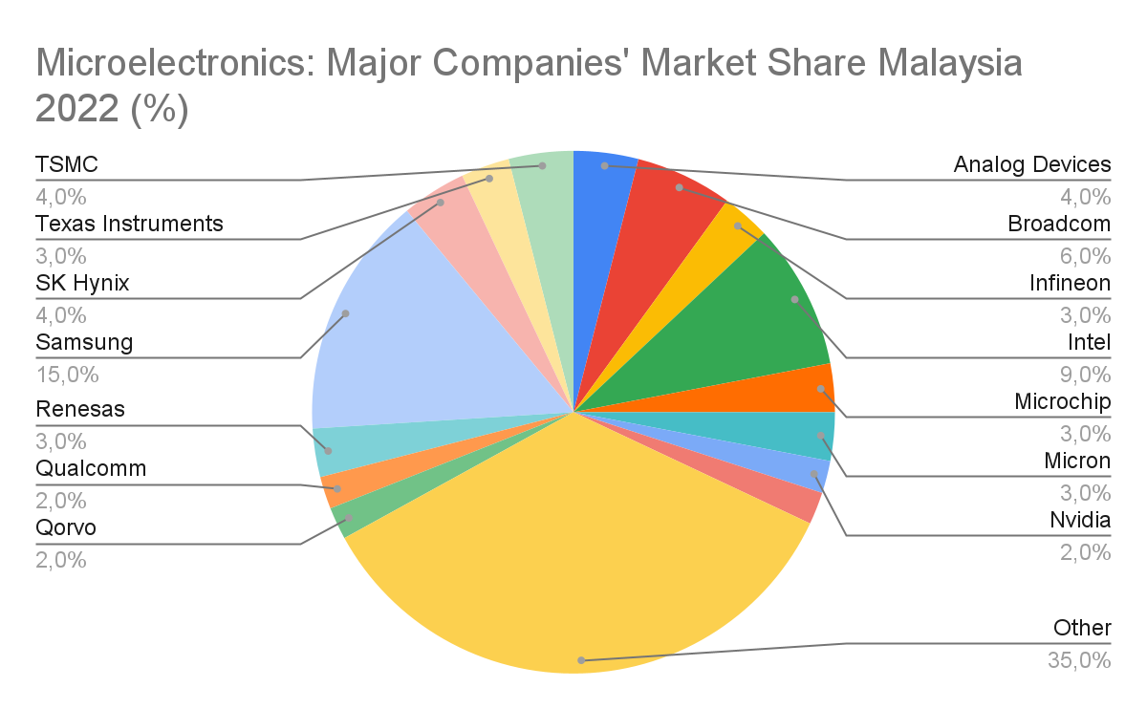
Figure 11. Semiconductors Major Companies’ Market Share Malaysia 2022 (%) (Source: compiled by the authors based on data from Statista)
The market concentration (HHI: 1676) is fairly lower than the global situation in the industry, but still indicates a moderately concentrated market.
According to Statista, the market is projected to grow at a CAGR of 9,10% throughout the period 2024 - 2027 resulting in a total revenue of the market of $ 22 bn by 2027, of which a great chunk comes from IC products (87,2%) (Statista 2023).
We expect however the growth rate to be slightly higher, boosted by the increasing “immigration” of Chinese companies, which, amid sanctions, are delocalizing the downstream operations of the value chain to Malaysia (the main exporter to the US) to continue dealing with American companies (Ruehl, 2024). Other ways for Chinese companies to avoid US sanctions are alliances and contractual forms, which drastically increased the amount of agreements between Chinese and Malaysian firms (Potkin & Ngui, 2023). No significant M&A deal was reported in the industry over the last 10 years, except Amkor’s acquisition of Toshiba in 2013.

2.2 AT&S’ Greenfield FDI in the Kulim Hi-Tech park, Malaysia
AT&S, headquartered in Loeben, Austria, is a global leader in the manufacturing of Advanced IC substrates which are used in a wide variety of industries, such as Cloud and Computing, Data centers and Connectivity and user devices (smartphones, computers, machines among the most important). Its main business areas at the current moment are PCBs, Advanced IC Substrates (its current core businesses) and Advanced Semiconductor Packaging. Despite packaging being the last added in the company’s portfolio, it represents a strategic priority for the company, especially with regard to its market potential and profitability (AT&S, 2023).
The company was founded in 1987 from the merger of several state owned enterprises in the Austrian Industry. After going private in 1994 it didn’t take much for the company to undertake the IPO (in 1999) and starting a process of Internationalization, firstly in India in the same year, then in China (2001) and Korea (2006).
It was in 2013 however that the company entered the IC substrate segment (previous core business was PCBs) by cooperating with the leading semiconductor manufacturer Intel in the Chinese facility located in Chongqing (Futurezone, 2013). The first production line started in 2016 / 2017.
AT&S operates 9 production sites: 2 in Austria, 4 in China, 1 in India, 1 in South Korea and 1 in Malaysia. As for now, almost total production of IC substrates happens in China and Austria, with the latter focused on the European market and lately (due to US sanctions to China) increasingly to the American Market.
The company’s objective is to reach 3,5 bn euros in revenue by the financial year 2026 / 2027 with a target EBITDA margin of 27% to 32%, to be one of the top three substrates players in the market (AT&S, 2023).
Spikes in NET CAPEX noticeable between 2014 - 2016 and 2019 - 2023 are directly traceable to expansions of the company’s main facilities. Firstly in Chongqing, and then the groundbreaking of the new Kulim factory in Malaysia, where the company already spent more than $ 1 bn dollars. The company plans to reach an overall investment of $ 1,85 bn (the largest in the company’s history), and to create over 6000 jobs in the country (AT&S 2022; MIDA 2022) (see figure 12).
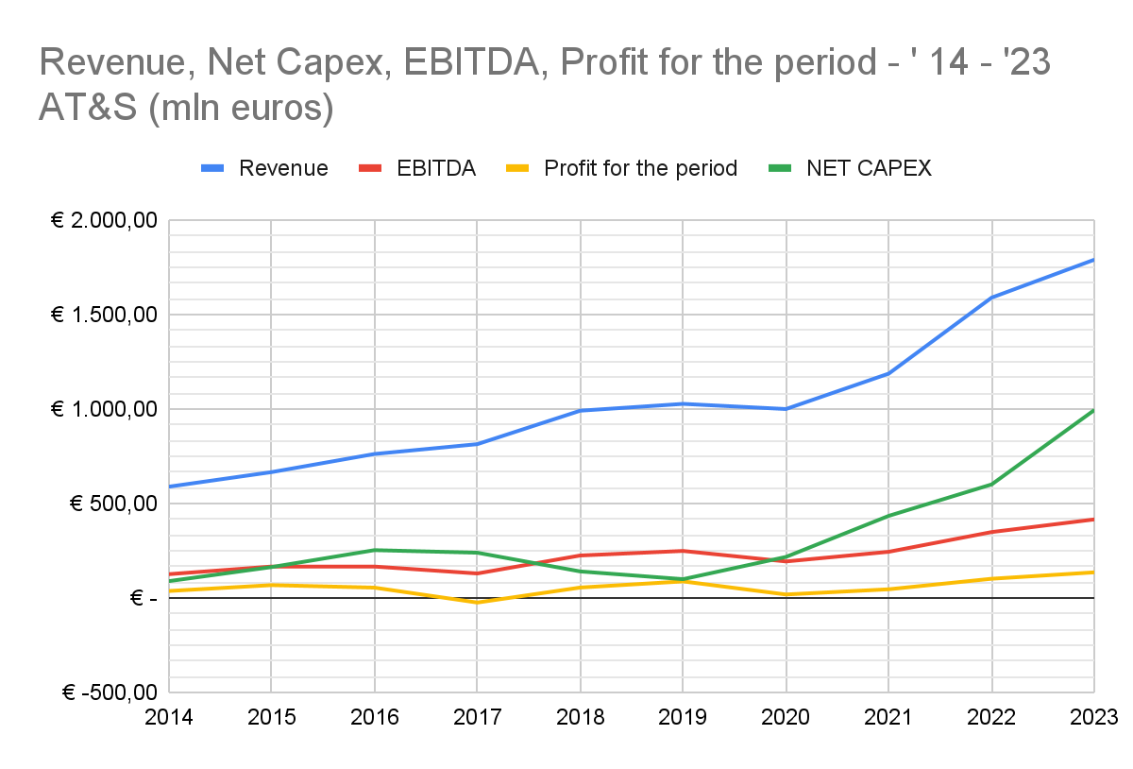
Figure 12. AT&S Financials ‘14 - ‘23 (Source: compiled by the authors based on data from AT&S)
Negotiations for the investment started in November 2020 between AT&S and the MIDA and concluded in October 2021 with the ground breaking ceremony which will lead to the construction of the ninth production site of the company (all the previous market entries were also carried out through greenfield FDI, except for the one in Korea, with the acquisition of TOFIC). The project is carried out with two leading manufacturers of high-performance computing semiconductors, which will also contribute to the financing of the project. The company will hold 100% of the shares (AT&S, 2022).
The plants will be built with an option of expanding further the capacity (up to $ 3 bn), which will depend “on the development of the market and the situation of a key customer” (AT&S, 2022). This real option to expand capacity is mainly due to current market situation in the microelectronics industry that alternates moment of low demand to moments of saturation, due mainly to the increase in adoption of electronic devices after the pandemic and the consequent changes in inventory level needs and supply chain concerns (AT&S, 2022).
The new plant in Malaysia will represent the largest production site in the segment of IC substrate manufacturing. The location, says Ingolf Schröder (COO of the company), has been chosen among several others to build the first manufacturing facility in South East Asia. Malaysia, and more in particular Kulim, represented the best choice for AT&S, with an extensive network of leading companies present in the area, proximity to materials suppliers and customers, and well tested infrastructure and supply chain.
Moreover, the fierce support given by the government and by the Malaysian Investment Development Authority “actively contributed to eliminating potential obstacles” (AT&S, 2022). Moreover, Andreas Gerstenmayer (CEO), adds on top of that the cruciality of the close cooperation with universities and other educational institutes of the region, which help to attract the most talented engineers in the area, mitigating therefore the risk deriving from fierce competition. In order to achieve this, AT&S’ employees already visited the University of Science Malaysia, to start to create a research and training network to boost a more rapid development of the company in Malaysia (AT&S, 2022). Similar initiatives (such as internship for students and Joint research projects) were carried out with five other selected universities to raise awareness into “the technologies and requirements of industrial enterprises” (AT&S, 2023).
In addition, we have to remember that Malaysia is now the major global contributor to semiconductor’s exports towards the US (Rane, 2024). In this sense, the US and more in general American companies, represent the main customers for AT&S, contributing for almost 75% of the total MNE’s revenue (see figure 13).

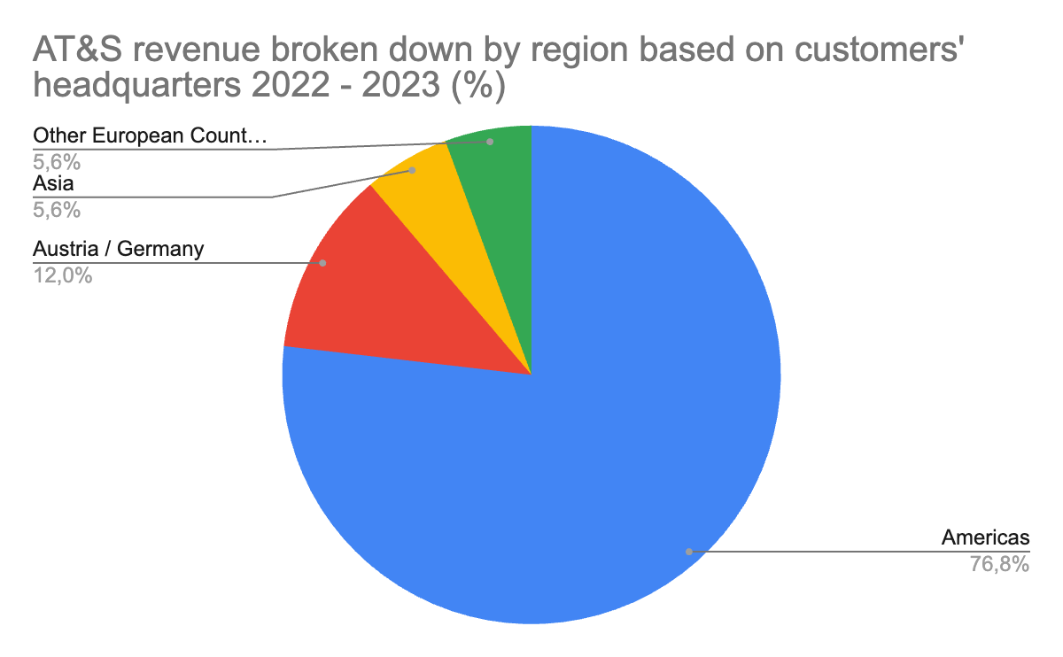
Figure 13. AT&S revenue by region based on customers’ headquarters for the financial year 2022 - 2023 (%) (Source: compiled by the authors based on data from AT&S)
As a consequence of the current market situation between China and the US, AMD, a major customer of AT&S, has recently announced a big expansion of its joint venture in Malaysia, quadrupling the current facility in terms of space and tripling it in terms of employees (MIDA, 2024; MIDA 2023). Reading the words of Andreas Gerstenmayer (CEO), AT&S, indeed built the first fab, exclusively to serve AMD (MIDA, 2024).
AT&S, as the first company to bring high-end IC substrates in China, got the opportunity to realize that several players (especially front end) were starting to delocalize their activities in Malaysia. This represented a big market opportunity for AT&S to be the first mover in the Malaysian market (MIDA, 2024).
In several additional conferences between AT&S and the MIDA it has been highlighted the bi-faceted character of this facility, where the company will carry out both manufacturing and R&D, aimed at “establishing a completely new technology sector in Malaysia” (MIDA, 2024).
A final consideration concerns the strategic objective of the company to become a top 3 player in the IC substrates subsegment. According to Yole Group’s intelligence the company is ranked eighth in 2022 among the players in this sub-niche, with a 6,4% share and $ 1,32 bn revenue deriving from IC substrates related activities (see figure 14).
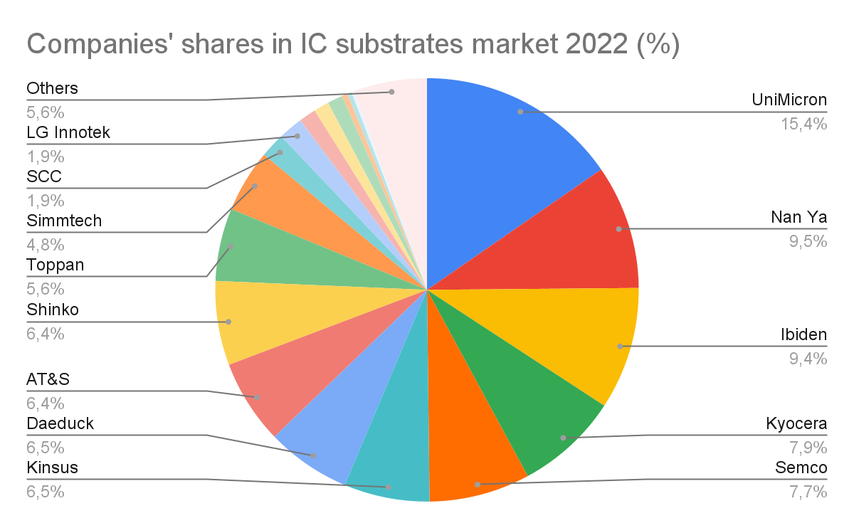
Figure 14. Companies’ shares in IC substrates market 2022 (%) (Source: compiled by the authors based on data from Yole Group)
The competition in this sub niche however seems to be significantly different from the overall microelectronics market, with an HHI of 800. This suggests a low level of concentration of the industry and increased competition.

2.3 Applied Engineering, Inc. Joint Venture with QES Group in the Batu Kawan Industrial park, Malaysia
Applied Engineering, Inc., is an American company founded in 1979 in the heart of the Silicon Valley and headquartered in San Jose, California. The company started out with a specific focus in servicing the manufacturing and assembly and packaging segments of the microelectronics industry. The over 40 years of experience in the sector (and especially in the equipment and tools segment) allowed the company to leverage its capabilities in other industries such as Medical devices and robotic manufacturing services (Applied Engineering). Indeed, despite the limited scale of its operations, over the years the company managed to establish important partnerships with major players operating within the industry, such as KLA Tencor (a critical supplier of services, tools and technologies) and LAM Research (critical supplier of semiconductor fabrication equipment).
At the moment of writing the company employs 171 workers and has a revenue which steams from $ 25 to $ 50 mln dollars per year. Despite the company already having a presence in South East Asia with a regional representative office in Singapore, before this Joint Venture deal, they were not present with operations in this regional market.
The Local Partner, QES Manufacturing Sdn. Bhd., is a wholly-owned subsidiary of QES Group ltd, a publicly listed Malaysian company established in 1991. The group has two core business divisions: manufacturing and distribution. The latter focuses on providing several solutions for a variety of industries, with semiconductor companies as main customers, while the first one focuses on assembly and testing, and several equipment services to ensure optimal performance. The company has a well diversified portfolio in the industry encompassing Equipment, Manufacturing, Materials and engineering solutions. The annual revenue of the company for the last official financial report is RM 264,4 mln (~ $ 55,8 mln).
The establishment of Applied Engineering Technology (M) Sdn Bhd (AET), the Joint Venture in partnership with QES Manufacturing Sdn. Bhd. (QES), therefore represents their first operations abroad (outside the US). Working on the project since December 2019, the parties (in July 2021) signed an agreement to establish a new plant in Batu Kawan Industrial Park which became fully operational in March 2022.
The Joint Venture company is established in order to provide their customers with “high-tech electro mechanical contract manufacturing services, from prototyping to high-volume production” (MIDA, 2021). More precisely, as reflected in QES group 2021 annual report, the joint venture will be targeted at expanding into “high technology semiconductor equipment making in Penang” but targeting also other industries such as medical devices, aerospace, defense and emerging technology (QES Group, 2022). At the ground breaking ceremony, QES group managing director added a note on the strategy that will follow in the next two years: stemming from “customer support in terms of assembly and integration” to reach, starting from 2025, capabilities of customized equipment design for their customers (Invest Penang, 2022).
The Joint Venture Agreement reflects a major share held by Applied Engineering, holding 70% of the Joint Venture, and a minority share held by QES Group (30%). The total value of the investment till the present moment was expected to be around RM 20 mln (~ $ 4,3 mln) according to the Malaysian Development Authority. In January 2024, however, QES group announced that the Joint Venture will receive an additional injection of RM 40 mln (~ $ 8,6 mln) to expand the facility and meet surging global demand for semiconductor manufacturing, bringing the total amount invested in the venture to $ 12,9 mln (Fatihah, 2024; Invest Penang, 2024).
As in a Joint Venture, differently from a Greenfield FDI, the parties involved are more, we will discuss the deal rationales taking into account also the Malaysian counterparty interests in the joint Venture.
As reflected in several announcements and interviews, following the establishment of the Joint Venture, the Malaysian partner started to send several key staff and technical personnel to Applied Engineering’s HQs in California in order to start the knowledge transfer and talent building capabilities (Invest Penang, 2022). This interest in receiving new technological skills is reflected in several additional interviews by also the institutional counterparties such as the Malaysian Investment Authority and the Penang Investment Institution.
On the other hand, as reported directly by Applied Engineering’s President Jack Yao, the main rationale for the deal lies in the Malaysian Environment (in terms of market and market growth potential) and the opportunity to open the company to the broader ASEAN regional market (Invest Penang, 2022). The same thoughts are remarked by Mr. Chew Ne Weng, president of QES group, highlighting the benefits for Applied Engineering of leveraging the well established network QES group has across China, ASEAN countries and other parts of Asia, starting from the Malaysian market (MIDA, 2021).
Additional words are dedicated to the supporting role the Malaysian Investment Development Authority had in “facilitating, supporting and expediting the company’s JV undertaking in Malaysia and finding a suitable partner” (MIDA, 2021).

Chapter 3: Research findings and Recommendations for International Microelectronics Companies and for further research

3.1 Research Findings: determinants affecting the choice of Joint Venture and Greenfield FDI in developing countries on the Malaysian example
In this final chapter we will match our analysis with the literature in order to extract our findings and devise, where possible, some recommendations for Microelectronics companies. We will then conclude our analysis by listing the limitations of our research and devise some new recommendations for scientific progress in the literature.
In order to complete our analysis we will divide the determinants based on the frameworks provided in our first chapter. We will then leave space for additional considerations not traceable in the literature.
Starting from Home and Host country determinants. In line with the literature these determinants have a rather moderating effect in the choice of entry mode.
Institutional Differences between the “home” market of those companies and the foreign market have not acted as “crucial factors” in either of the cases. However we acknowledge and find support in the role local partners play in reducing the risk perceived by the MNE and therefore favor the establishment of a joint Venture (especially when other determinants as the lack of resources and of international experience, such in the case of Applied Engineering, are present).
We also believe that, given the cruciality of this industry and the attention it gains from governments, the importance of finding a local partner is decreased by the support provided by local governments in the Investment process. This may therefore push the MNE to establish a wholly owned subsidiary to fully capitalize on market opportunities. However, where the main objective of the MNE is market development, the joint venture may be a preferred entry mode as it allows access to a network of suppliers, customers and logistics in a faster and cheaper way.
As for the Incentives and Government support, our findings suggest that the literature is indeed confirmed in terms of the role countries play in incentivizing or disincentivizing both forms of FDI to enter a market. With the example of AT&S in Malaysia we have a clear picture of the role financial incentives played in the deal and the role the Malaysian Investment Development Authority played in facilitating all procedures and development of the project.
Similar words can be spent on Applied Engineering’s Joint Venture in Malaysia, where the MIDA highly facilitated the whole process, including helping the American Company to find a Joint Venture Partner.
Our possible conclusion in this case in the choice of the two companies to employ two different entry modes relies either on Firm’s Level Determinants (i.e. the difference in resources, both financial and non-financial the company have) or on Investment Level Determinants. In the latter case the companies’ objectives differ: AT&S wants to become a top tier company in the market and might therefore need to appropriate more profits and capitalize on its advantages, while, on the other hand, sees Malaysia's investment as a gateway to enter the broader regional market. Moreover, the attitude Applied Engineering has with regard to QES coworkers, openly training them, highlights that they are not considering knowledge spin offs as major determinants.
As for the presence or absence of environmental hazards (i.e. having a well established network of customers, suppliers and in logistics), and their effect in reducing the perceived risk of the MNE, our findings suggest that the literature is indeed confirmed.
Firstly, as explicitly reported by Applied Engineering the choice of a Joint Venture was indeed influenced by the need of finding a partner, which already had a well-established network in the area and could therefore help to expand the American Company’s operations in the regional market. Secondly, as we have learnt from AT&S case study, the importance of finding a Joint Venture partner is decreased by the role played by local institutional authorities, by having customers present in the market and most likely by the level of International experience of the company. Here again, other determinants played a major role, such as the firm’s level and investment level determinants.
Other risks are not particularly common in Malaysia and are therefore not relevant in these specific cases and industry.
For the Trade barriers and closed markets we did not find enough grounding to draw a conclusion on supporting or not supporting the literature. We however believe that the weight this factor plays in this specific research and industry is rather trifling and limited to the dispute between US and China.
For home country support, no specific information was found in our research to sustain or disapprove the role this determinant plays.
Now, as for industry and market level determinants. Considering the Industry uncertainty, the institutional environment uncertainty of developing markets and the risk associated with the amount invested, we can find support in AT&S’ greenfield FDI, which suggests that the company needed to control operations closely.
Moreover the company clearly stated that it reserved for itself the real option to build a second fab depending on market conditions. This real option to expand capacity is mainly due to the current market situation we have described in the analysis. On the other hand Applied Engineering seems not to align with previous research, most likely due to a secondary role these determinants played in the choice of the company.
Continuing with these determinants, the increasing costs to build a fab, should have disincentivized AT&S to undertake a Greenfield FDI in Malaysia according to previous literature. Despite acknowledging the investment as the biggest in their history, the company did not resort to other entry strategies, highlighting the major role other kinds of determinants play in the company’s choice.
Our conclusion finds light support also in the overall industry trend with evidence of several big projects carried out by manufacturing companies to build fabs through greenfield FDI. The real option to expand its capacity may have granted to the company enough flexibility, while mitigating at the same time the risk deriving from the increased financial commitment and from other resource constraints.
Similarly their objective to increase market share and reach the top positions in their niche, may have disincentivized them to collaborate with other players and capture the full profit deriving by their relationship with AMD.
An additional determinant is the one represented by Organizational legitimacy. In the first case the theory finds support in AT&S case study as the company consistently employed greenfield FDI to enter new markets over time (especially developing ones). The company employed M&A strategies just on one occasion: to enter the Korean Market.
Regarding entry strategies of other companies in the Malaysian Market we find support especially regarding joint ventures with several different deals announced over the past years both by big and small companies. Although no direct mention was made by Applied Engineering executives on the legitimacy of such entry mode we can clearly see that there has been a trend, especially by smaller companies to set up joint ventures in partnership with local partners operating in the same or adjacent industries.
Similarly previous literature highlighted how joint ventures were almost obligatory to enter China till 2008 due to various regulatory reasons. Despite the opening of the Chinese market starting in 2008, the analysis of entry modes we carried out shows that China is the only market in our sample with a great majority (70%) of Joint Ventures. This may be indeed due to the legitimacy this entry mode choice gained among industry players when certain conditions are met (e.g. in terms of lack of financial resources).
Concerning investment level determinants we have to start from AT&S. AT&S is a leading enterprise in the market. To avoid technology spillovers and ensure proper management is a main determinant for AT&S choice to have maximum control over its assets. Although we did not find direct mention of this determinant in company’s announcements and executives' interviews, we have found proof in our statistical analysis. The dataset shows a moderate correlation (r = 0,49) between the number of patents a company holds and the entry mode choice (Greenfield FDI). We therefore find support for the literature. As the number of patents decrease, consequently the choice of Greenfield FDI as an entry mode.
Secondly, the operational flexibility which Greenfield FDI can bring. AT&S executives admitted that they need this flexibility in order to develop their operations depending on market conditions and the development of a key customer (AMD). We therefore find support for this second point, which is in turn tied to the goal of fully capitalizing on the market opportunity. They won’t have had this chance by sharing profits and revenues with a Joint Venture partner.
Thirdly, Market seeking. This determinant is openly announced by Applied Engineering’s executives as the main goal for their market entry. We can extend this determinant to Joint Ventures as well.
Continuing with Joint Ventures, a major determinant is identified in creating new advantages and especially in the learning effect this type of organization has. Moreover, the ability to pool capitals and other types of resources is also mentioned in the literature. Despite not having found (in the case study, nor in the industry analysis) direct reference to acquire tech and innovation abilities, we find mention of this from the QES side (the Malaysian partner of Applied Engineering). The company has openly stated that to acquire tech capabilities is their main objective and has already sent engineers in America to acquire the needed expertise to collaborate. On the other hand, the American Company acquired expertise in dealing with that specific regional market and in adjacent areas by collaborating with QES Group.
Firm’s level determinants seem to find full support and hold true in our case study with no exclusion. Indeed, if we compare the two case studies we see how AT&S, being bigger from a financial and operational point of view, as well as having greater International experience, decided to pursue a Greenfield FDI, while Applied Engineering, with less resources (both financially and non-) decided to pursue a Joint Venture.
Similarly, also the determinant of reducing the liability of foreignness finds support in Applied Engineering decision to establish a joint venture. The company’s executives highlighted the role QES will be playing in facilitating the company’s operations in the new market. Concerning this determinant, we have also to take into account the role institutional actors are playing in Malaysia.
Aside from the case studies, we found support for the roles technological and financial capabilities play in the choice between these entry modes in our statistical analysis.
As additional findings, we refer to the tools AT&S used in order to reduce the risks of greenfield FDI, especially with regard to timing, financial risk and limited knowledge of the foreign environment. AT&S showed that, despite those are usually considered major determinants preventing Greenfield FDI, there are several tools (corollary activities and real options) that can help the company mitigate the effect of those variables. This is crucial for companies such as AT&S, which is technological leader.

3.2 Recommendations for International Microelectronics companies
Drawing information from the two case studies and our findings we may formulate two major recommendations for International Microelectronics Companies.
Firstly, developing the network before fabs become operational is a valuable resource to mitigate the risk deriving from the “foreignness” of the MNE.
In this industry, this work is highly supported by institutional players in the host market, which have a profound interest in developing in-house leadership in the sector. In both case studies we saw how the MIDA and other institutional players supported and facilitated companies in administrative tasks and to grow their network of suppliers and customers.
Moreover, other types of strategies can be implemented by companies to mitigate the risks that may derive from hiring new employees in a foreign market or from an insufficient qualification of workforce. AT&S consistently grew its network by cooperating with several different universities and institutions. It launched joint research programs, programs to introduce new students to their “corporate life”, hiring sessions, and hackathons. These tools may not just serve as a way to facilitate the hiring process and the training of new employees, but are also generally seen as a good way to “advertise” the company and make it appealing to search for a job there.
Secondly, there are ways to mitigate the risk deriving from financial commitment that do not imply pooling financial capitals with a joint venture partner. In this industry, market leaders are well aware of the role incentives play in reducing the financial burden of an investment, which takes time to be realized (on average 3 to 5 years to build a new fab from scratch). But our consideration extends well beyond that point. If timing is not a major concern and there is enough managerial experience in terms of planning, a real option to further expand capacity may be an invaluable resource for the company. In this case AT&S carried out the biggest investment in its history, and planned the investment as a two-staged strategy with the second fab to be built depending on the developments of the market.
This real option to expand for AT&S carries several strategic implications which may be useful for other microelectronics companies worldwide:
- Risk Mitigation capabilities. Both valuable for small and bigger firms with have diverse competitive advantages. Once it’s established, as a strategic priority, the need to avoid knowledge spillovers, Greenfield FDI may be the only option. The increased financial burden this strategy carries can be reduced by a real option to expand.
- Flexibility in scaling operations in terms of market demand and technological advancements. This is crucial in industries such as the microelectronics one, where the speed of technological innovations may cause demand to surge unexpectedly, and where global economic factors highly affect supply and demand.
- Technological leadership. In case the company is building a state of the art facility, technologically advanced for the average of the sector, having the opportunity to continuously invest in new capacity or to adapt the facility to new technologies may be vital to maintain their competitive edge.
In the choice between entry modes Joint Ventures are often seen as a major alternative for companies who are approaching a new market as they allow for risk mitigation and pooling of financial capitals, thereby reducing the risks deriving from financial commitment. However, there are many tools that can mitigate these risks and that can be useful for companies, which prefer to have direct and full control over their operations abroad, avoid technology spillovers and build a long term relationship with that market. Other entry modes, i.e. trade strategies, may not allow for that, and aggressive strategies such as acquisitions may not be able to provide these advantages.
Greenfield FDI is often seen as a Long Term Commitment by governments, especially in case of projects where amounts invested are significant and at the same time allows to protect the company core capabilities from knowledge spinoffs.
As we have learnt from AT&S’ case study this signal of commitment by the company is often perceived positively by the country, which extends the support well beyond financial and operational considerations but also to network building. Three areas are mainly of interest:
- Financial Support and Tax Incentives;
- Technological Advancement. Partnerships with research centers, universities and other scientific institutions;
- Local Workforce development. Support in the coordination of hiring activities may ensure availability of talent and also that they receive the right training from the outset. These may cause problems in case of an acquisition or other forms of entry strategy, where employees may not be aligned with company’s standards and objectives.
These advantages are present also in smaller deals, such as Applied Engineering’s one, signaling that this type of benefits do not exclusively derive from the amount invested but rather from the technological advancement of the company. Furthermore, Joint Ventures may provide additional benefits, not present in Greenfield FDI cases, by linking the company operations with an already existing and well rooted supply chain, customer base, and talent pool. This allows the company to scale up in a quicker way and reduce the liability connected with foreignness. This happens without losing control over operations abroad and sets up an asset which complies with local regulations, environmental standards and labor laws from the outset. These concerns might be increasingly important in future years in developing markets.

3.3 Limitations and Recommendations for further research
To conclude our paper we will list the limitations of our research and devise some recommendations for further analysis.
We will start with general limitations and recommendations concerning the whole body of our research and will move further with specific limitations regarding the four main dimensions we researched.
Starting from general limitations we may identify three major areas of improvement in our research.
The first one relates to the use of case studies. In our opinion, although case studies might be indeed one of the best ways to carry out new research and produce fresh and relevant findings, its validity may not always be extended to the entire industry. The multi-faceted asset of this sector does not allow us to capture the full essence of the industry with merely two case studies. This is mainly due to two factors.
Firstly, players in the industry are diverse in terms of operations and this triggers consequently diverse requirements when investing abroad or entering a new market through other types of strategies. Some determinants are specific to the segment of the value chain and thus are not really relevant for others. For instance, the increasing cost to build a fab fits well AT&S’ case study but could not be extended to an IP or EDA company, simply because they won’t have the need to build a fab unless they decide to vertically integrate their operations.
Secondly, some determinants may be intrinsic to the specific company or sometimes even to the specific deals, which may additionally limit the validity of the findings. We therefore suggest two possible courses of action for further research. One, may be to limit the scope of the study to a specific segment of the value chain to better qualify the determinants and its validity to the specific study and produce more relevant results. The second one would be to focus on more general determinants which are not directly tied just to the business scope of the company to produce results which are relevant to the whole industry.
The second limitation refers to the use we made of statistical methods in our research preferring the use of case studies. We produced some findings which are related to the quantitative analysis we made in our 2.1 section but for further research we recommend using more sophisticated statistical methods to test the relevancy of certain variables and carry out robustness tests to assess the validity of variables analyzed. In particular, we deem considerably relevant for the industry the impact that the increased screening activity over Mergers and Acquisitions may have on the choice of companies to undertake a Greenfield FDI or a Joint Venture as preferred entry modes.
Thirdly, we posed limited attention to the corollary activities companies carry out to sustain their main entry mode. We suggest in future research to pay particular attention to all these kinds of activities and the effect they have in mitigating the role of certain determinants. It can be done by consulting official companies reports, local sources such as Investment Authorities, Governmental organizations, Industry Reports and Magazines, and also investigating universities’ websites.
Now, moving to more specific recommendations regarding the four dimensions we analyzed, we found that particular interest in previous research was devoted to Host Country determinants, leaving uncovered the home country dimension and the impact it could have on the choice of entry mode made by International Microelectronics Companies. Although we believe that the host country dimension is by nature more important when assessing market entry modes in International Business Research, we also think that in strategic industries such as the one we analyzed the home country policy may play a significant role in the choice of entry mode. The case of China has been already analyzed in previous research but not much attention has been devoted to other markets. We suggest further research in the area by taking as example case studies of countries, which are developing their respective microelectronics industries. This could give more insights on the home country policies favoring FDI over other strategies or wholly owned subsidiaries over joint ventures. This may be relevant especially for:
- Governments that have a financial interest or enhanced control in the companies undertaking the investment;
- Governments which are promoting the developments of specific critical industries and of “national champions”;
- Sectors which are deemed to be of strategic importance for national development and national security, such as the Microelectronics one;
This may have a significant impact on the perceived level of risk and financial commitment of the company, as well as include some other types of considerations, which favor or prevent the company in undertaking a specific entry mode.
As for the host country dimension we suggest to examine more in detail the role local institutions have in facilitating the process of setting up a subsidiary abroad through Greenfield FDI. As we have learnt from the Malaysian example, the role governments play may extend well beyond mere financial incentivization but touch important areas such as network building and administrative procedures facilitation. Despite the fact that financial incentives play a major role, reducing the perceived risk deriving from the financial commitment, these support in more operational and day-to-day tasks may have a positive impact on another strategic consideration made by companies: timing and innovation.
As for Industry and Market determinants of entry mode choice we found challenging to define in a straightforward and concise way institutional and industry uncertainty. Not having carried out a statistical analysis on the correlation between these variables and the choice of entry mode, we were not able to assess the importance all these variables have in choosing one entry mode over others. We suggest further research to carry out first-hand interviews with industry’s executives to clearly identify parameters which are relevant to this specific choice. We also suggest carrying out statistical analysis to assess the impact that industrial uncertainty has on the choice of entry mode.
As for Investment Level Determinants we did not find evidence of the correlation between increasings in costs to build a fab and the establishment of a joint venture. Despite the relationship seems pretty straightforward, especially when taking into account resource constraints, AT&S case study seems counterintuitive in respect to this determinant. We may suggest statistically testing these determinants over a larger pool of market entries. Additionally we recommend to take into account other determinants, which were present in general research but not in the literature pertaining the microelectronics industry, i.e. CEO characteristics, and the business scope of the foreign subsidiary in relation with the core capabilities of the company.
For Investment Level and Firm Level Determinants, as we mentioned earlier in this section a major limitation may be represented by the limited disclosure on companies’ strategies and may therefore be advisable to carry out interviews with companies executives in order to return more precise and relevant results.

Conclusions
In this paper we analyzed the determinants influencing International Microelectronics Companies (in specific AT&S and Applied Engineering) in their strategic choice of entry mode towards developing markets, with a particular focus on Malaysia. Our analysis aimed at identifying specific factors that drive the popularity of greenfield FDI and Joint Ventures towards developing markets in the Industry.
The literature review facilitated the process of mapping and prioritizing the determinants, while our industry and statistical analysis along with the case studies allowed us to test the validity of previous research and of the four dimensions we analyzed.
The findings of our research show that primary considerations companies have when entering a foreign market in the microelectronics industry are to maintain strict and exclusive control over foreign operations for market leaders and to to develop new capabilities and pool resources for smaller companies. Moreover, financial disbursements, while at its highest, can be mitigated by several other internal and external factors (such as managerial capabilities, company’s network and government’s incentive and support).
Similarly the required time to start from scratch new operations seems to lose relevance thanks to governmental support and managerial experience, which speed up operational processes and open the way for new network building.
In conclusion, in an industry such as the microelectronics one, amid growing environmental concerns, resource constraints and increasing innovation speed, both Joint Ventures and Greenfield FDI represent valuable resources for companies, depending on their strategic motivation. Understanding which are those risks and constraints and how they impact companies choices, is the first step to gather the right set of tools to mitigate them and ensure that companies’ objectives are met.

References

Allen & Overy (2023). Global trends in merger control enforcement. A&O Shearman Official Website. Retrieved 26 February 2024. Available from: https://www.allenovery.com/global/-/media/allenovery/2_documents/news_and_insights/campaigns/global_trends_in_merger_control_enforcement/2023/global_trends_in_merger_control_enforcement.pdf?rev=4ef851b3a88a4d31b3e8c6ee1094a4c4
Applied Engineering (n.d.). Applied Engineering Technology - Malaysia Facility - about Applied Engineering: Company – Applied Engineering. About Applied Engineering | Company – Applied Engineering. Retrieved 26 March 2024. Available from: https://www.appliedengineering.com/aetmalaysia.
Applied Engineering (n.d.). Electromechanical contract manufacturing, Custom Coil Design, Precision Machine Shop. About Applied Engineering | Company – Applied Engineering. Retrieved 1 March 2024. Available from: https://www.appliedengineering.com/
Arthos Corporate Finance (2023). Industry Insight: Semiconductor Sector Report Semiconductor M&A: IoT is driving demand and M&A transactions. Retrieved 1 March 2024. Available from: https://www.arthos.de/fileadmin/template/public/pdf/arthos-semiconductor-12-2023.pdf
AT&S (2021). Annual Report 2020_21 - AT&S. AT&S Official Website [Online]. Retrieved 30 March 2024. Available from: https://www.ats-report.net/en/
AT&S (2022). Annual Report 2021_22 - AT&S. AT&S Official Website [Online]. Retrieved 30 March 2024. Available from: https://www.ats-report.net/en/
AT&S (2023). Annual Report 2022_23 - AT&S. AT&S Official Website [Online]. Retrieved 30 March 2024. Available from: https://www.ats-report.net/en/
BCG & SIA (2021). Strengthening The Global Semiconductor Supply Chain In An Uncertain Era, Retrieved 21 November 2023. Available from: https://www.bcg.com/publications/2021/strengthening-the-global-semiconductor-supply-chain
BCG & SIA (2019). Strengthening The Global Semiconductor Supply Chain In An Uncertain Era, Retrieved 21 November 2023. Available from: https://www.semiconductors.org/strengthening-the-global-semiconductor-supply-chain-in-an-uncertain-era/
Beamish, Paul W. & Lupton, Nathaniel C., (2016). Cooperative strategies in international business and management: Reflections on the past 50 years and future directions. Journal of World Business, Elsevier, 51(1), pp. 163-175.
Blanchard B. , Vengattil M. & Kalra A. (2023 July 11). Foxconn dumps $19.5 billion Vedanta chip plan in blow to India. Reuters. Retrieved 12 March 2024. Available from: https://www.reuters.com/technology/foxconn-pulls-out-india-chip-jv-with-vedanta-2023-07-10/.
Buckley P. J., Casson M. C. (1976). The Future of the Multinational Enterprise. MacMillan: London (2nd Ed. 1991; Anniversary edition 2002).
Chen, H., & Hu, M. Y. (2002). An analysis of determinants of entry mode and its impact on performance. International Business Review, 11(2), 193-210.
Chiao, Y.-C., Lo, F.-Y., & Yu, C.-M. (2010). Choosing between wholly-owned subsidiaries and joint ventures of MNCs from an emerging market. International Marketing Review, 27(3), pp. 338-365.
Damodaran A. (2024 January 5). Useful data sets. Damodaran Online. Retrieved 11 March 2024 Available from: https://pages.stern.nyu.edu/~adamodar/New_Home_Page/data.html
Dettoni Jacopo (2022 January 31). The 2021 investment matrix. fDi Intelligence – Your source for foreign direct investment information - fDiIntelligence.com. Retrieved 12 March 2024. Available from: https://www.fdiintelligence.com/content/locations/global/the-2021-investment-matrix-80638.
Dunning John , (2001). The Eclectic (OLI) Paradigm of International Production: Past, Present and Future. International Journal of the Economics of Business, Taylor & Francis Journals, 8(2), pp. 173-190.
Elango B., Sambharya R. B., (2004). The influence of industry structure on the entry mode choice of overseas entrants in manufacturing industries. Journal of International Management, 10(1), pp. 107-124.
Flamm K. & Reiss P. (1993). Semiconductor Dependency and Strategic Trade Policy. Brookings Papers on Economic Activity. Microeconomics, 1, pp. 249-333.
Fatihah A. (2024 January 18). QES group invests RM40 million in new plant, doubling manufacturing capacity. Business Today. Retrieved 12 March 2024. Available from: https://investpenang.gov.my/qes-group-invests-rm40-million-in-new-plant-doubling-manufacturing-capacity/
Futurezone.at. (2013, June 14). AT&S Kooperiert mit Intel. Futurezone. Retrieved 12 March 2024. Available from: https://futurezone.at/b2b/ats-kooperiert-mit-intel/24.598.015
Gartner (2024 January 16). Gartner says worldwide semiconductor revenue declined 11% in 2023. Retrieved 12 March 2024. Available from: https://www.gartner.com/en/newsroom/press-releases/2024-01-16-gartner-says-worldwide-semiconductor-revenue-declined-11-percent-in-2023
Glowik, Mario. (2020). Market Entry Strategies. Internationalization Theories, Concepts and Cases (3rd edition). 10.1515/9783110653113.
Gopalan S., Rajan R. S., & Duong L. , (2019). Roads to Prosperity? Determinants of FDI in China and ASEAN, Chinese Economy, Taylor & Francis Journals, 52(4), pp. 318-341.
Gugler & Siebert (2007). Market Power versus Efficiency Effects of Mergers and Research Joint Ventures: Evidence from the Semiconductor Industry. The Review of Economics and Statistics. 89(4), pp. 645–659.
Henisz, J. W., Macher, J. T., (2004). Firm- and Country-Level Trade-offs and Contingencies in the Evaluation of Foreign Investment: The Semiconductor Industry, 1994–2002. Organization Science, 15(5), pp. 537-554.
Hill, C. W. L., Hwang, C. L., & Kim, H. (1990). An eclectic theory of the choice of international entry mode. Strategic Management Journal, 11(2), 117-128.
Hu, S. H. & Ma, H. Y. (2012). The Influence of Host-Country’s Environments on the FDI Entry Mode Choice of Chinese Companies. Business and Management Research. 1.
IC Insights (2022 August 30). Four large agreements prop up 2022 semiconductor M&A; total. IC Insights | Semiconductor Market Research. Retrieved 6 March 2024. Available from: https://www.icinsights.com/news/bulletins/four-large-agreements-prop-up-2022-semiconductor-ma-total/
Imboden, Matthias & Han, Han & Stark, Thomas & Lowell, Evan & Chang, Jackson & Pardo, Franklin & Bolle, Cristian & Corro, Pablo & Bishop, David. (2014). Building a Fab on a Chip. Nanoscale. 6.
IMF (April 2023). Groups and Aggregates Information. Retrieved 1 May 2023. Available from: https://www.imf.org/en/Publications/WEO/weo-database/2023/April/groups-and-aggregates#da
Invest Penang (2023 September 20). How Malaysia fostered a semiconductors industry that brought in investors like Tesla & Intel?. InvestPenang. Retrieved 5 March 2024. Available from: https://investpenang.gov.my/how-malaysia-fostered-a-semiconductors-industry-that-brought-in-investors-like-tesla-intel/
Invest Penang (2022 March 9). [press release] AETM’s confidence in Malaysia results in the setting up of a 20,000 square feet manufacturing facility in Pulau pinang. Invest Penang News. Retrieved 21 November 2023. Available from: https://investpenang.gov.my/press-release-aetms-confidence-in-malaysia-results-in-the-setting-up-of-a-20000-square-feet-manufacturing-facility-in-pulau-pinang/
Invest Penang (2024 January 18). QES Group Invests RM40 Million In New Plant, Doubling Manufacturing Capacity. Invest Penang News. Retrieved 21 November 2023. Available from: https://investpenang.gov.my/qes-group-invests-rm40-million-in-new-plant-doubling-manufacturing-capacity/
Irwin-Hunt, A. (2023 May 3). The world’s top semiconductor investors. fDi Intelligence – Your source for foreign direct investment information - fDiIntelligence.com. Retrieved 26 February 2024. Available from: https://www.fdiintelligence.com/content/data-trends/the-worlds-top-semiconductor-investors-82433
Irwin-Hunt, A. (2023 February 1). The 2022 investment matrix. fDi Intelligence – Your source for foreign direct investment information - fDiIntelligence.com. Retrieved 26 February 2024. Available from: https://www.fdiintelligence.com/content/data-trends/the-2022-investment-matrix-81976
Irwin-Hunt, A. (2024 February 1). Greenfield FDI Data live: Key trends: Alex Irwin-Hunt posted on the topic. LinkedIn. Retrieved 26 February 2024. Available from: https://www.linkedin.com/posts/ajih_the-2023-investment-matrix-activity-7158888482470313984-AUL0
Johanson, J., & Vahlne, J.-E. (1977). The internationalization process of the firm—A model of knowledge development and increasing foreign market commitments. Journal of International Business Studies, 8(1), pp. 23-32.
Jung, J., Beamish, P. & Goerzen, A. (2010). Dynamics of Experience, Environment and MNE Ownership Strategy. Management International Review, 50, pp. 267–296
Khan, Hounshell & Fuchs, (2018). Science and research policy at the end of Moore’s law. Nature Electronics, 146.
Koc, C., & Jacobs, J. (2024 January 1). US pushed ASML to block Chinese sales before January deadline. Bloomberg.com. Retrieved 26 February 2024. Available from: https://www.bloomberg.com/news/articles/2024-01-01/us-pushed-asml-to-block-chinese-sales-before-january-deadline
Kratko, I. G. (2022, December). Doing Business in Russia. Lecture.
Ku K. C., Gurumurthy C. K., Kao H. P. (2007). Inter-firms collaboration of joint venture in IC foundry business, Technovation,27 (5), pp. 296-305.
Lee, Y. H.. (2010). A Resource-Based perspective of entry mode choices of Electronic Components industry into China. 2010 International Conference on Future Information Technology and Management Engineering, FITME 2010. 1. pp. 540 - 545.
Lee, J. L., Hawkins, M., & Bloomberg. (2024 March 5). AMD, like Nvidia, tried to make a weaker chip for the Chinese market-but Washington says it’s still too powerful. Fortune Asia. Retrieved 26 February 2024. Available from: https://fortune.com/asia/2024/03/05/amd-tried-to-make-weaker-china-chip-biden-export-controls-china-semiconductors-blocked/
Li & Xiong (2022). Host Country’s environmental uncertainty, technological capability, and foreign market entry mode: Evidence from high-end equipment manufacturing MNEs in emerging markets. International Business Review, 31(1).
Li, R., Huang, S., & Chen, S. (2011). The role of Taiwan in the global microelectronics industry. Journal of Industrial and Business Economics, 38(3), pp. 275-289.
Luo & Lemanski, (2016). FDI Strategies of Chinese Companies in the Electronics Industry: Motives, Locations, and Entry Mode Choices. The challenges of Bric Multinationals.
Macher, J. T., Mowery, D. C., & Simcoe, T. S. (2002). The influence of intellectual property policy on the foreign direct investment decision of firms: evidence from the global semiconductor industry. Journal of International Business Studies, 33(3), pp. 287-308
Martin, X., Mitchell, W., Swaminathan, A., & Stewart, D. (2010). Organizational ambidexterity: A comprehensive framework. Strategic Management Journal, 31(1), pp. 1-24.
MIDA (2024 January 24). AT&S inaugurates Southeast Asia’s first IC substrates manufacturingplant valued RM8.5 billion in Kulim, Malaysia. Retrieved 14th April 2024 . Available from https://www.mida.gov.my/media-release/ats-inaugurates-southeast-asias-first-ic-substrates-manufacturingplant-valued-rm8-5-billion-in-kulim-malaysia/
MIDA (2023 March 27). AMD Malaysia to expand with new state-of-the-art facility in Penang. Retrieved 14th April 2024 . Available from https://www.mida.gov.my/mida-news/amd-malaysia-to-expand-with-new-state-of-the-art-facility-in-penang/
MIDA (2021 July 15). American high-tech company, Applied Engineering Inc.. setting-up joint venture operations with Malaysian QES Manufacturing Sdn. Bhd.. Retrieved 14th April 2024 . Available from https://www.mida.gov.my/media-release/american-high-tech-company-applied-engineering-inc-setting-up-joint-venture-operations-with-malaysian-qes-manufacturing-sdn-bhd/
MIDA (2024 February 7). Tech: AT&S’ deal with AMD to help elevate Malaysia’s E&E Value Chain. MIDA. Retrieved 16 March 2024 Available from: https://www.mida.gov.my/mida-news/tech-ats-deal-with-amd-to-help-elevate-malaysias-ee-value-chain/
MIDA (2022 August 2). Malaysia has a preferable ecosystem to attract more semiconductor investments. MIDA. Retrieved 6 March 2024. Available from: https://www.mida.gov.my/mida-news/malaysia-has-a-preferable-ecosystem-to-attract-more-semiconductor-investments/
MSIA (2023 february 21). 2022 E&E survey. Retrieved 21 March 2024. Available from: https://msia.org.my/folder_upload/pdf_file/e-Booklet_MSIA 2022 E&E Survey.pdf
Ogasavara M. (2013). The effects of own- and other-prior entry modes in the internationalization of Japanese multinational companies in the electronic sector. Journal of Asia Business Studies, 8(1).
Park, C. (2020). Market entry strategies in a high-tech successive generations market: a case study of three semiconductor firms with different entry modes, Journal of Business & Industrial Marketing, 35(11), pp. 1751-1766.
Potkin F. & Ngui Y. (2023 December 18). Exclusive: Chinese firms look to Malaysia for assembly of high-end chips, sources say. Reuters. Retrieved 12 March 2024. Available from: https://www.reuters.com/technology/chinese-firms-look-malaysia-assembly-high-end-chips-sources-say-2023-12-17/
Qes Group (2022). Annual Report 2021 - QES Group. QES Group Official Website [Online]. Retrieved 1 April 2024. Available from: https://www.qesnet.com/wp-content/uploads/2022/04/QES-Group-Berhad-Annual-Report-2021.pdf
Qes Group (2023). Annual Report 2022 - QES Group. QES Group Official Website [Online]. Retrieved 1 April 2024. Available from: https://www.qesnet.com/wp-content/uploads/2022/04/QES-Group-Berhad-Annual-Report-2021.pdf
Qes Group (2024). Annual Report 2023 - QES Group. QES Group Official Website [Online]. Retrieved 1 April 2024. Available from: https://www.qesnet.com/wp-content/uploads/2022/04/QES-Group-Berhad-Annual-Report-2021.pdf
Raff, H., Ryan, M. J., & Stähler, F. (2009). The choice of market entry mode: Greenfield investment, M&A and joint venture. International Review of Economics & Finance, 18(1), pp. 3-10.
Rane (2024 March 20). Malaysia’s place in the race for semiconductor business: Rane. Stratfor. Retrieved 6 March 2024. Available from: https://worldview.stratfor.com/article/malaysias-place-race-semiconductor-business
Rapp H. P., Möbert J. & Deutsche Bank (2022). Extraordinary semiconductor cycle triggered by one-time events, cyclical and geopolitical effects. Deutsche Bank Research Official Website. Retrieved 1 April 2024. Available from: https://www.dbresearch.com/PROD/RPS_EN-PROD/PROD0000000000522983/Extraordinary_semiconductor_cycle_triggered_by_one.pdf?undefined&realload=eNVjoWAUwVgAdisM3sx6otynMSxwl1JyPF5ecV7SsZRU3X1pZu08VlHbYodRPTJV
Rizwan T. & Chen W. (2011). Strategic motivations of australian and New Zealand manufacturing foreign direct investments in international markets. Asian Academy of Management Journal. 16. 131-148.
Robles, F. & El-Ansary, A. & Root, F. (1988). Entry Strategies for International Markets. Journal of Marketing.
Ruehl M. (2024 March 11). Malaysia: The surprise winner from US-china chip wars. Financial Times. Retrieved 2 April 2024. Available from: https://www.ft.com/content/4e0017e8-fb48-4d48-8410-968e3de687bf
Schaller R. R. (1997). Moore’s Law: past, present and future. IEEE Spectrum.
Shen, K. N., Puig, F. S., & Paul, J. A. (2017). Foreign market entry mode research: A review and research agenda. International Business Review, 26(6), pp. 1123-1133.
SIA (2024 february 5). Global Semiconductor Sales Decrease 8.2% in 2023; Market Rebounds Late in Year (2024). Semiconductor Industry Association Latest News. Retrieved 16 February 2024 Available from: https://www.asml.com/en/investors/annual-report/2023
Statista (2023 November). Semiconductors - malaysia: Statista market forecast. Statista. Retrieved 16 March 2024 Available from: https://www.statista.com/outlook/tmo/semiconductors/malaysia
Statista (2023 November). Semiconductors - worldwide: Statista market forecast. Statista. Retrieved 16 March 2024 Available from: https://www.statista.com/outlook/tmo/semiconductors/worldwide#global-comparison
UNCTADSTAT (2023 November 3). Merchandise: Intra-trade and extra-trade of country groups by product, annual. UNCTADSTAT. Retrieved 19 March 2024 Available from: https://unctadstat.unctad.org/datacentre/dataviewer/US.IntraTrade
WSTS (2017). WSTS Product Classification 2018. World Semiconductor Trade Statistics. Retrieved 12 March 2023. Available from: https://www.semiconductors.org/wp-content/uploads/2018/07/Product_Classification_2018.pdf
Yang J.; Chen, J. D. A. (2023 November 9). Will Apple’s record-breaking R&D spending pay off with the M3 chip series? Digitimes. Retrieved 26 February 2024. Available from: https://www.digitimes.com/news/a20231108PD205/apple-m3-chip-ic-design-distribution-chips+components.html
Yeung H. W. , 2022. Explaining Geographic Shifts of Chip Making toward East Asia and Market Dynamics in Semiconductor Global Production Networks. Economic Geography, Taylor & Francis Journals, 98(3), pp. 272-298.
Yinug F. (2009). Challenges to Foreign Investment in High-Tech Semiconductor Production in China. Journal of International Commerce and Economics, pp. 1-30.
Yoffie D. B. (1993). Foreign Direct Investment in Semiconductors. Foreign Direct Investment. University of Chicago Press, pp. 197 - 230.
Yole Group (2023 November 14). Advanced IC substrates: Taiwanese companies lead the market. Yole Group Press Releases. Retrieved 28th March 2024. Available from: https://www.yolegroup.com/press-release/advanced-ic-substrates-taiwanese-companies-lead-the-market/
Zia A. (2023 September 18). Semiconductor R&D spending by country: Top 12. Yahoo! Finance. Retrieved 26th March 2024. Available from: https://finance.yahoo.com/news/semiconductor-r-d-spending-country-204326067.html
Zia A. (2023 November 21). Semiconductor R&D spending by company: Top 12. Yahoo! Finance. Retrieved 26th March 2024. Available from: https://finance.yahoo.com/news/semiconductor-r-d-spending-company-151257226.html

